Report on Survey of Local Economic Development Partnerships on the Impact of Covid-19

This report was produced within the framework of the Mayors for Economic Growth (M4EG) Initiative funded by the European Union. Its contents are the sole responsibility of the author and do not necessarily reflect the views of the European Union.

September 2020

Preface
The main objective of the EU-Initiative Mayors for Economic Growth (M4EG) is “to support the LAs in the Eastern Partnership (EaP) countries to become active facilitators for economic growth and job creation in the region. The project will encourage and support LAs in EaP countries to design and implement Local Economic Development Plans (LEDPs) and strengthen the technical skills and capacities of LAs to implement economic strategies in line with the principles of good governance and sound financial management” (Project Terms of Reference, p. 15). See www.m4eg.eu for more information on the M4EG Initiative.

PHASE I of the M4EG Initiative runs from January 2017 to December 2020. The Covid-19 outbreak in March 2020 has had a major impact on many - if not all - of the municipalities involved as partners in the project, both those already implementing their plans and those currently actively involved in drafting them. It was already clear from the beginning of the pandemic that some sectors are likely to suffer more than others across the region. Nevertheless, the sectoral impacts of the virus are not as yet properly quantified or well understood.
In May 2020 it was therefore decided to carry through a survey assessment among M4EG Signatories in the Eastern Partnership countries in order to learn and understand in more detail how the pandemic concretely has affected the municipalities’ economies and their battle for economic growth and job creation given their different compositions and conditions.
The assessment is solely focused on the economic consequences of Covid-19 to date and economic recovery prospects within a 2-3 years’ timeline.
Hopefully, this report will give Local Authorities (LAs) some understanding and insight in the problems of the economy caused by the pandemic, and most importantly will give ground for evidence-based proposals for recovery of the economy. The main audience of the report is representatives of Local Governments in the EaP countries, but also national and regional authorities as well as national and international donors can get knowledge on how they can assist in revitalization of the economy in the territories.
Finally, and most importantly it must be mentioned that the assessment was carried through in a consultative process involving the LAs, local private sector, CSOs, academic institutions, etc. through the already established platforms of the Local Economic Development Partnerships. Each municipality has conducted relevant analysis and discussions and agreed on the answers to the standardized questions of the assessment. This means that for each question the Partnership has had to find a consensus response, which will assist the LAs to identify and understand the economic consequences of the pandemic in their municipalities and thus help them re-think their actions in the nearest future.
--------------------------
The M4EG Secretariat - Tbilisi, September 2020.

Executive summary
A survey was undertaken of 216 Local Economic Development Partnerships (LED Partnerships) representing M4EG Acting Members in the six Eastern Partnerships states – Armenia, Azerbaijan, Belarus, Georgia, Moldova and Ukraine - in May-June 2020 to assess the impact of Covid-19. Each partner was asked to provide a rigorously based assessment of important sectors of their local economies across a range of dimensions: to employment, growth and municipal revenue. They were asked for their assessment regarding both how Covid-19 has affected them so far and on their expectations of the impact of Covid-19 over a 2-3 year time horizon. After assessing the impact of Covid-19, they were then asked to consider whether new sectors might have emerged as potential sources of economic development in the wake of Covid-19, and to identify sectoral priorities for investment.
The main aims of the survey were to use the information collected:
- To assist the partners to understand the impact of Covid-19 and to consider how they might respond;
- To assist the EU in providing appropriately targeted support for the partners going forward;
- To assist in the next stage of the current project in working most effectively with the partners and the Commission as it rolls out its ongoing work.
The results of analysis of the data that were collected are presented in detail in the main report below, which provide details of how countries and sectors compare in terms of the impact of Covid-19. This comparative analysis is supplemented by country-level results in a series of appendixes.
Key Findings
- There are significant differences across countries – though it is important to note that the findings are affected by the relatively small numbers of Partners and therefore sectors in some countries, particularly in Azerbaijan.
- The most important sectors for LED Partnerships were food and beverage processing, agriculture, and tourism and accommodation.
- The sectors generally most affected by Covid-19 to date however do not include agriculture but instead the most negative consequences have been felt by tourism and food services.
- Expectations about the impact of Covid-19 over the next 2-3 years are much more varied by sector; indeed, there is negative correlation between the impact of Covid-19 to date and evaluations of future prospects, with many examples of positive expectations in future in areas very negatively impacted now.
- Relatively few LED Partnerships identified new sectors as pockets of future growth, and those that did mentioned a very broad range of potential growth areas; nonetheless, tourism was identified by many LED Partnerships where this is not currently an important sector.
- Priorities for future investment are focused on sectors that are generally of current importance to the local economy – chiefly, agriculture and tourism – even if agriculture in particular has not been badly hit by Covid-19 to date.
- Optimism among the LED Partnerships is relatively high for the future; however, we find somewhat surprising that optimism is a bit higher in places where growth has currently been harder hit.
- LED Partnerships in local economies with high levels of grey economy have a significantly more negative estimate of the impact of Covid-19 to date.
- LED Partnerships with higher levels of in-migration of workers have more positive expectations about the impact of Covid-19 over the next 2-3 years and higher levels of optimism; optimism is also stronger in LED Partnerships that are in a mix of urban and rural settlements than either purely rural or urban areas.
Policy implications
1. Our analysis suggests that the current impact of Covid-19 may not be a good guide to future policy in response. Recovery is broadly expected, often especially in the worst hit sectors. Sectors that were identified to be priorities for external support remain those that were identified as already the most important – agriculture, tourism. Moreover, areas that were identified by a number LED Partner as potential new sectors for development indicate that tourism is perceived to have broader possibilities than before the pandemic.
2. The negative relationship between current negative experience of Covid-19 and future expectations and optimism is an interesting finding. The mechanisms that produce this result are not obvious from the data itself, however. Two compatible possibilities may be in play. The first is psychological: those LED Partnerships that have yet to experience the impact of Covid-19 may anticipate the worst; while those who have had the most experience of Covid-19 may have built a degree of immunity by considering and taking actions that might build resilience in the future. The important point here is all stakeholders should be very careful not to take current often devastating experience of covid-19 as the principal basis on which to make future policy. Expectations of the future among Partners may be a better guide to the direction of external resources in the next period.
3. Careful attention needs to be paid to national circumstances and local sectoral specificities. While there is quite broad agreement on some areas of current economic pain that are also often the most likely future positives for Partners – agriculture, tourism, food services - there are very numerous mentions of highly diverse new sectors that might produce economic benefits. Focussed work with Partners to elaborate understanding of these new sectors is recommended.

Introduction
1. Objectives of the survey
It was clear at the beginning of April that the Covid-19 outbreak had had a major impact on many if not all of the municipalities involved as partners in the project. What was unclear was exactly the degree to which each sector and each country had been affected. Were some sectors and countries more badly hit than others? Were the most important sectors to the LED Partnerships hit or only those that were more peripheral? What was the perspectives of the partners on the future impact of Covid-19 on growth, employment and municipal revenue? What new sectors might have emerged as potential sources of future economic development in the wake of Covid-19?
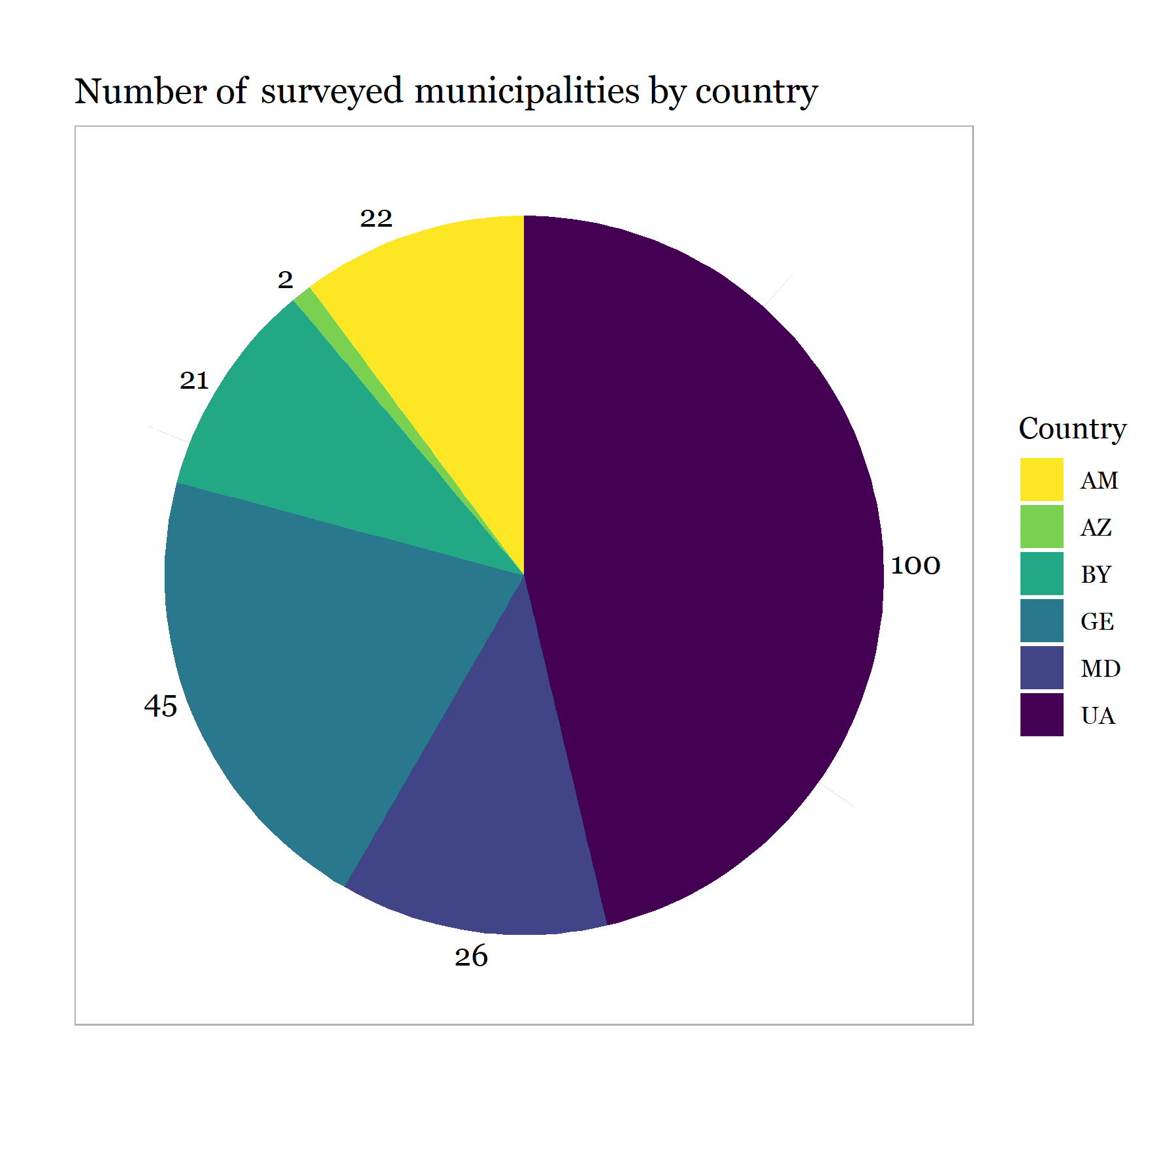
These are the questions that the report sets out to answer, with the aims:
- To assist the partners to understand the impact of Covid-19 and to consider how they might respond;
- To assist the EU in providing appropriately targeted support for the partners going forward;
- To assist in the next stage of the current project in working most effectively with the partners and the Commission as it rolls out its ongoing work.

The data that underpin this report are the result of a survey that was conducted in May-July 2020 of 216 LED Partnerships representing M4EG Acting Members in 6 countries: Armenia, Azerbaijan, Belarus, Georgia, Moldova, and Ukraine. The number of surveyed LED Partnerships in each country is shown in the figure above. Note that the data do not claim to be representative of the full range of economic activity of each country. That is particularly true of Azerbaijan where there are only two Partnerships covering only a relatively limited number of economic sectors. However, the data do give the most accurate assessment available of the impact of Covid-19 on each LED Partnership and their expectation for future impact and how it might have opened up new opportunities.

Each Partnership was asked to complete a brief questionnaire in which they provided numerical scores to their experiences, prospects and priorities across a number of economic dimensions – employment, growth and municipal revenue. Additional information was collected about other characteristics of the locality. Partnerships were asked to arrive at their judgements through a process of internal discussion involving all stakeholders in the partnership (the full survey instrument with details of how the survey was explained and framed to the LED Partnerships and the full questionnaire is provided in Appendix G below.)
The results below provide information that is disaggregated by most common sectors of economy and by country. Additional analysis considers whether the impact of Covid-19 is felt more strongly in certain types of municipality (rural/urban). These findings allow us to provide estimates from municipal partnerships to highlight:
- The sectors and groups that have been most affected.
- The priorities for recovery.
- The sectors in which assistance could be of greatest support.

1. Description of main sectors by country and settlement type, including importance of each for employment, growth, local revenue and the LDP as a whole
We started by asking each LED Partnership to provide a list of the most important sectors to the economy in their locality. Respondents could choose from a list of 26 different sectors that we reduced to 10 different sectors and an ‘other’ category. We grouped sectors together that were very similar and kept the most important sectors as separate categories. The results are shown in two figures that follow and point to the following in terms of importance across four economic dimensions. The first figure shows which sectors were selected as important in each country. Each municipality was asked to choose four sectors, the figure indicates what percentage of the selected sectors falls into each sector category (adding up to 100% per country). across all countries, we find that retail, food services, agriculture, tourism, and food and beverage processing are most commonly selected as important sectors, with retail as the most important sector as about 20% of the selected economic sectors falls under the retail category.

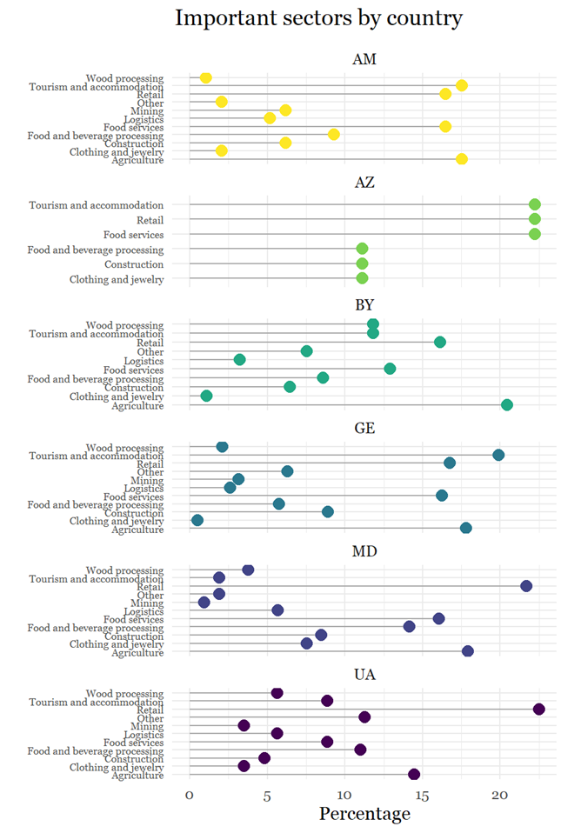

The second figure compares the importance of these economic sectors across four economic dimensions: employment, economic growth, municipal revenue, and the importance of each sector for the implementation of the Local Economic Development Plan (LEDP) that had been elaborated in each municipality under the M4EG Initiative. We find the following sectors to be important on these four economic dimensions, though it is important to note that a sector – in particular mining – may be very important when it is present but is a relevant sector in only a relatively small number of LED Partnerships:

- Employment – mining, agriculture and tourism.
- Economic growth – mining, agriculture, tourism, and food and beverage industry
- Municipal revenue – mining.
- For the LED Plans – agriculture, tourism, and food and beverage industry.

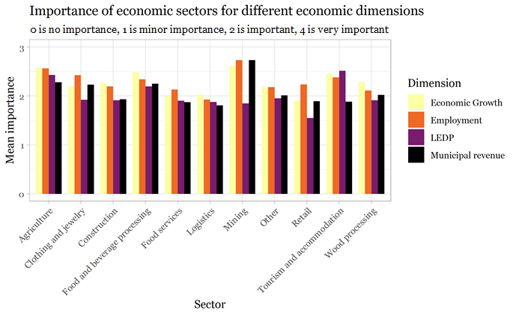

2. Impact to date of Covid-19 by sector
We next asked each LED Partnership to assess the impact to date of Covid-19 on the previously selected sectors of economy along the following three dimensions: employment, growth and municipal revenue in their municipality, and aggregated the received responses by country. We also calculated the overall impact on each sector based on an additive scale of each of the three dimensions. Results for these questions are shown in the figures that follow, based on the following scale:
- 1 = Positive impact - this would be the case if the Covid-19 epidemic and the related restrictive measures resulted in the sector’s growth.
- 0 = No significant impact – this would be the case if the sector’s operations currently continue to the same scale.
- -1 = Significant negative impact – this would be the case if the Covid-19 epidemic has made a clear difference but activities are currently continuing without large scale disruption.
- -2 = Major or devastating negative impact – this would be the case if the Covid-19 epidemic and the related restrictive measures have reduced activities to a dangerous degree or have stopped activities more or less entirely.
The results point to the following broad picture by sector and country:
- Employment - major to devastating impacts have been felt particularly in tourism and food services, but with minor impact in mining and agriculture.
- Growth – major to devastating impacts have been felt particularly in tourism and food services, but with minor impact in mining and agriculture.
- Municipal revenue - major to devastating impacts have been felt particularly in tourism, less so in food services, but with minor impact in mining and agriculture
- The retail sector is quite variable in how it has been impacted.
- Moldova and Ukraine have been worst hit across multiple sectors, with Moldova especially experiencing negative effects in tourism and food services with some municipalities also experiencing negative effects in mining as well.
- Additional regression analysis showed LED Partnerships located in urban centres and those with high levels of informal economy were significantly more likely to experience negative impacts of Covid-19.

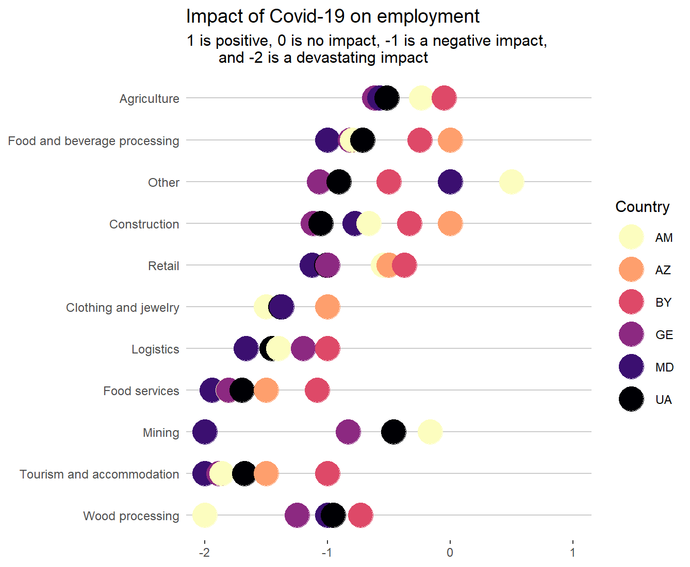
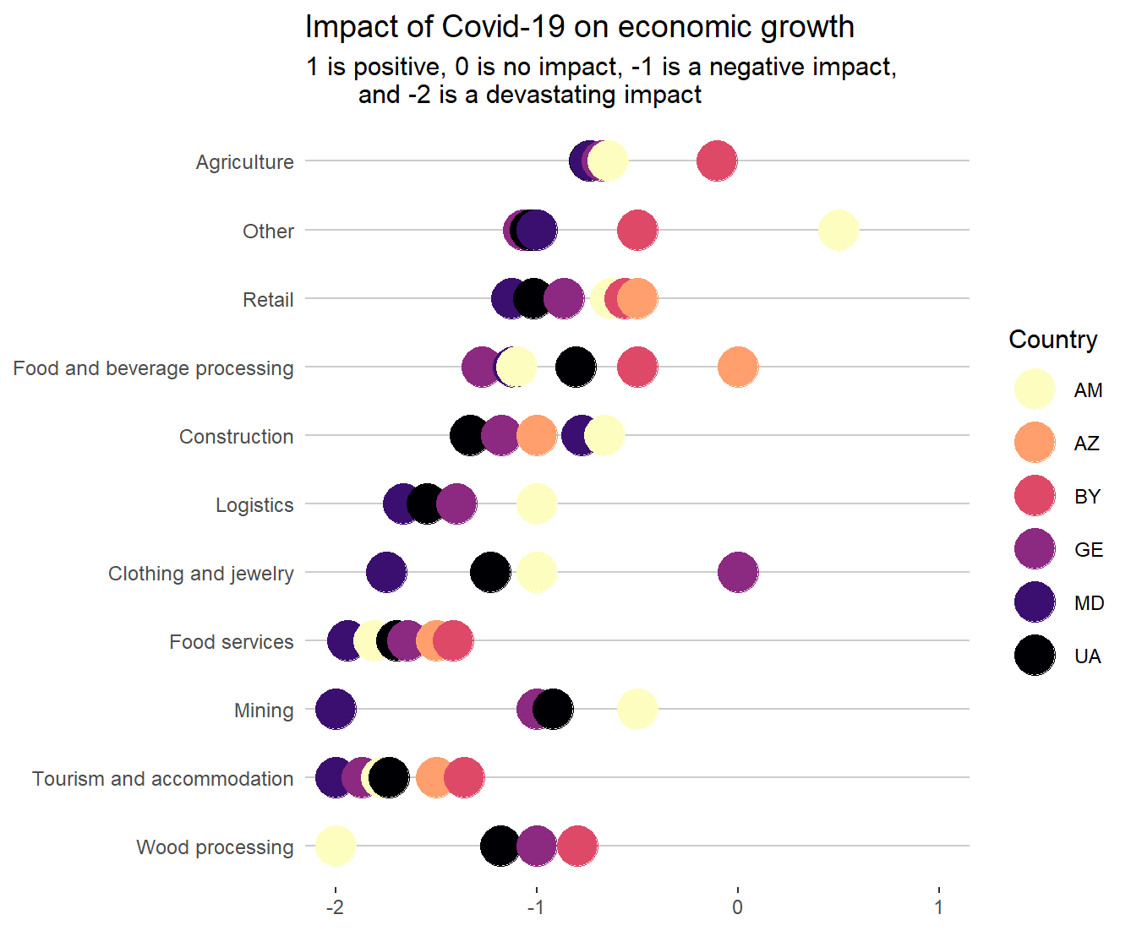
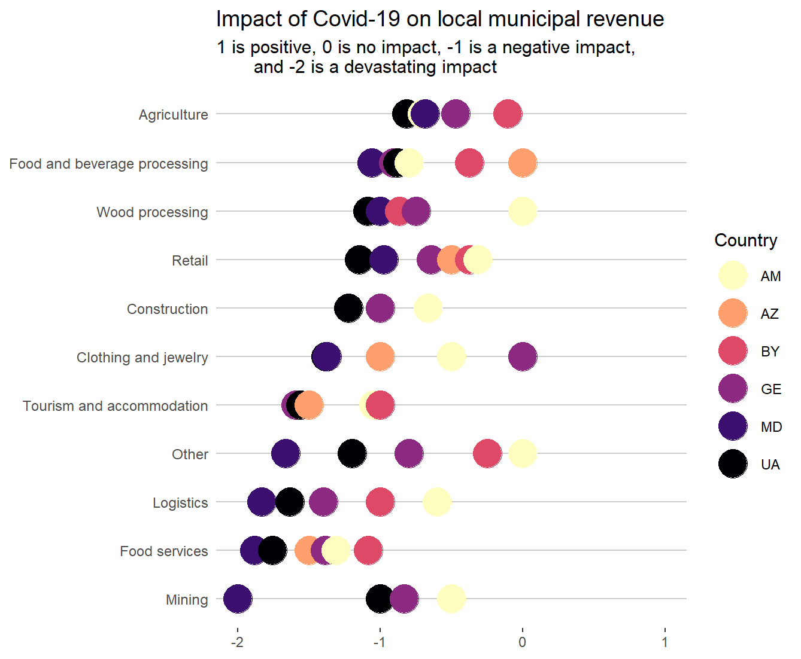

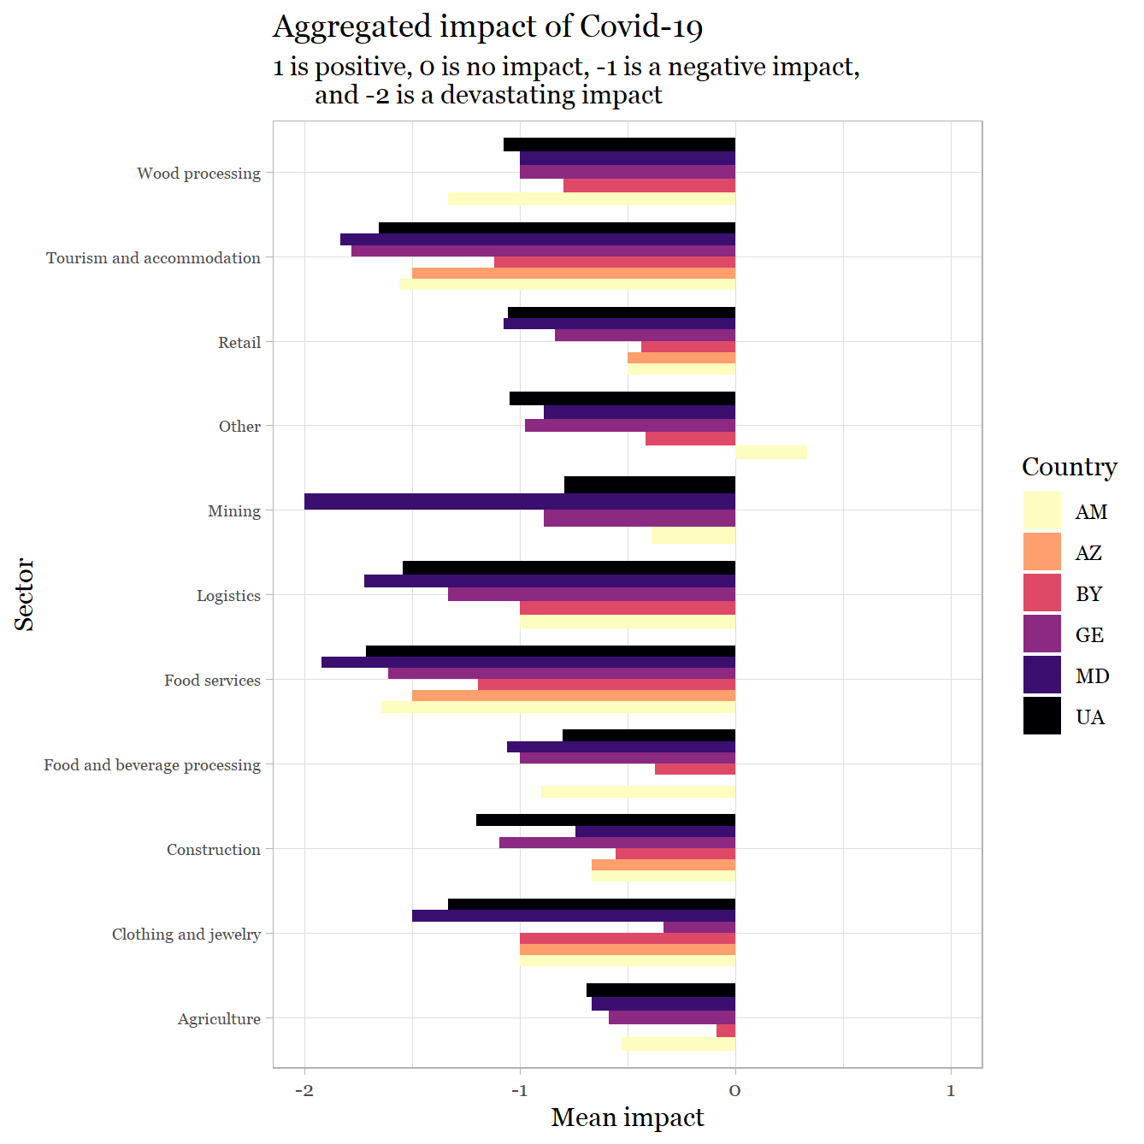

3. Impact of Covid-19 on sector over the next 2-3 years
We next asked each LED Partnership to assess the impact they expect over the next 2-3 year of Covid-19 on employment, growth and municipal revenue in their municipality. As with current impact, we also calculated the overall impact based on an additive scale of each of the three dimensions. Results for these questions are shown in the figures that follow, based on the following scale:
- 1 = Transformative – this would be the case if the sector’s performance can be expected to be better than before Covid-19.
- 0 = No significant change – the sector’s performance can be expected approximately the same as before Covid-19.
- -1 = Notable downturn – this would be the case if the sector’s performance is expected to be somewhat lower than before Covid-19.
- -2 = Major decline – this would be the case if the sector’s performance could be expected to fall significantly behind the level before Covid-19.
The results point to considerable variation across sectors and countries:
- Strongly negative expectations are still evident in some countries – clothing in Moldova and Ukraine, mining in Moldova, wood processing in Armenia, tourism in Armenia, Moldova and Ukraine.
- However, there is a much more positive outlook in many sectors over 2-3 year horizon.
Especially positive in agriculture (Georgia, Belarus), food and beverages (Azerbaijan, Belarus, Georgia), retail (Azerbaijan), and especially tourism in Georgia.
- The contextual characteristics of LED Partnerships (urban-rural, grey economy) are not significantly associated with future expectations of the impact of Covid-19, though there is a weakly significant (p<.05) effect of higher optimism for municipalities of greater levels of in-migration.
- What appears to matter the most is current experience with Covid-19 but in a surprising direction:
  - those LED Partnerships that have been hit particularly hard are significantly less likely to have negative expectations for the future (correlation of current impact and impact in 2-3 years r=-.23);
  - regression analysis shows that negative current impact on growth and municipal revenue was significantly associated with more positive future expectations.

The negative relationship between current negative experience of Covid-19 and future expectations and optimism is an interesting finding. The mechanisms that produce this result are not obvious from the data itself, however. Two compatible possibilities may be in play. The first is psychological: those LED Partnerships that have yet to experience the impact of Covid-19 may anticipate the worst; while those who have had the most experience of Covid-19 may have built a degree of immunity by considering and taking actions that might build resilience in the future.

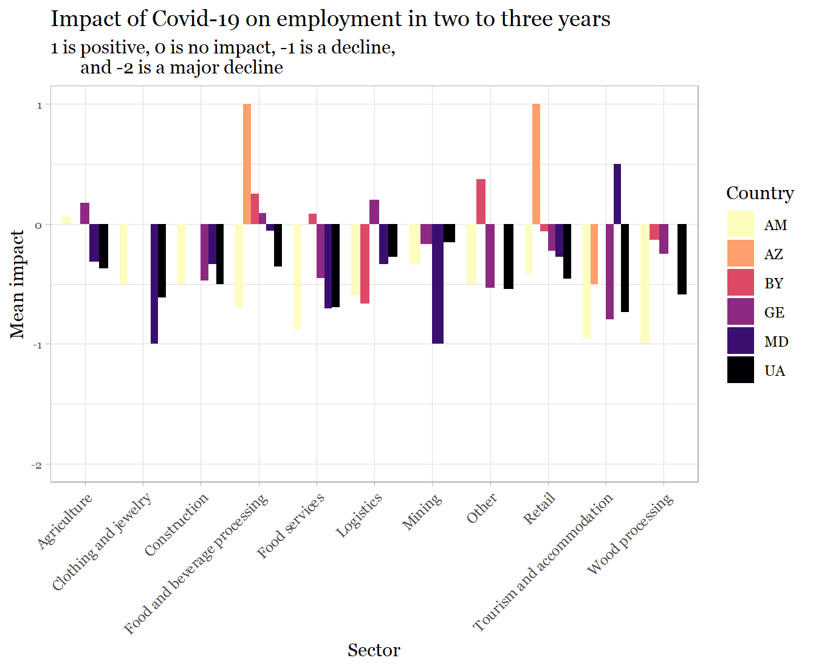
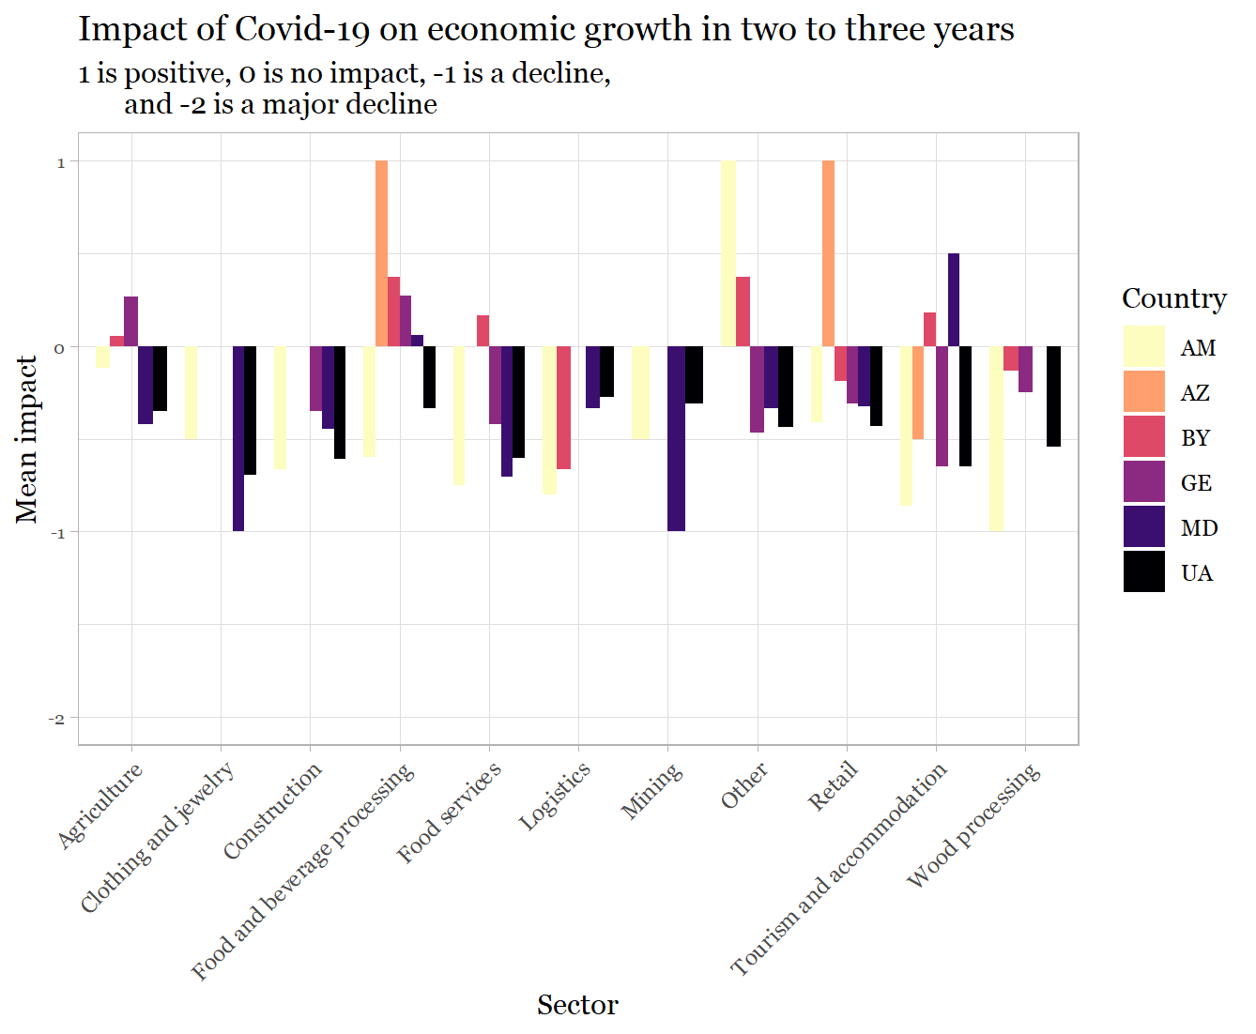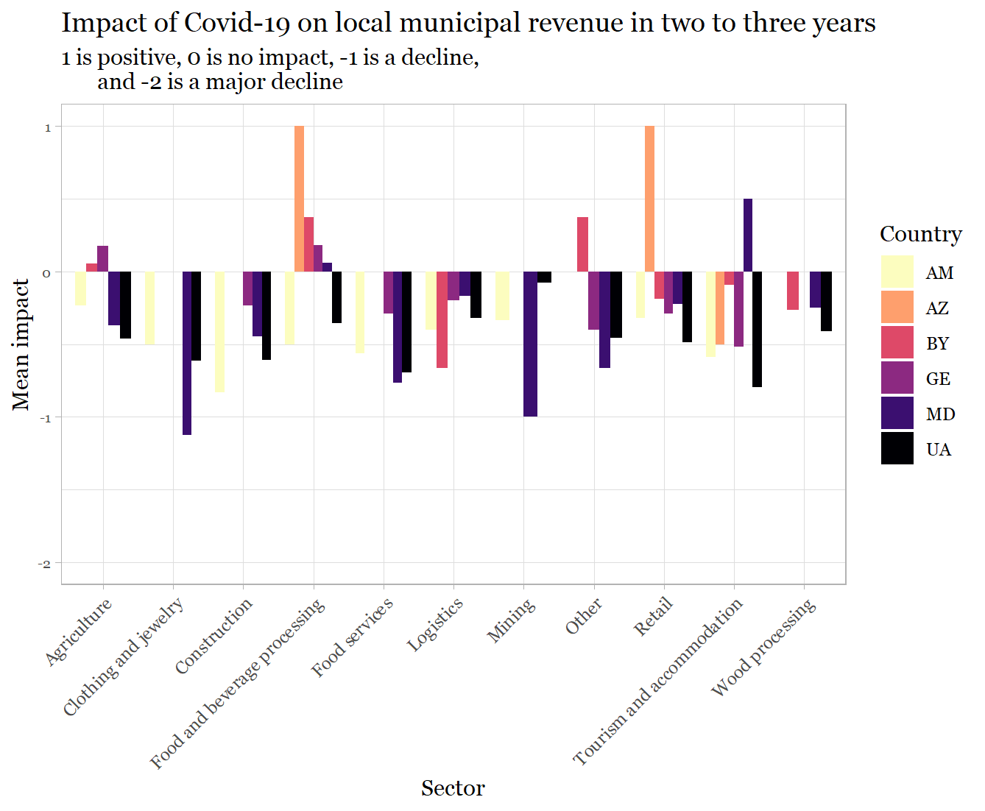

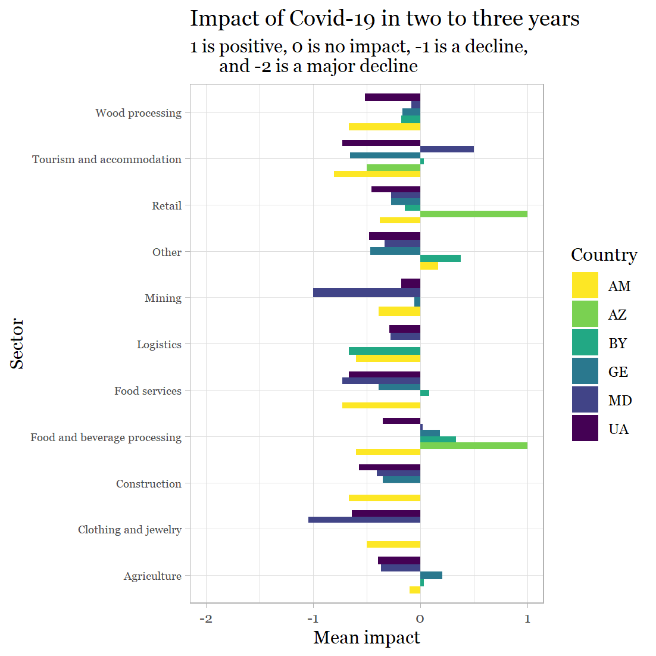

4. New sectors as pockets of growth
We next asked the LED Partnerships if they could identify new sectors, which were not important in their local economy before that have become potential growth poles/pockets of growth in the post Covid-19 situation. The results are shown in the two figures below. In the first figure we show how often certain sectors have been mentioned. Recall that we re-grouped the initial 26 different sectors into 10 and an ‘other’ category based on similarity and how often sectors were mentioned. The first figure shows how often sectors were mentioned. The second figure zooms in on the ‘other’ category and shows which sectors were mentioned. Note that these results skew the image towards countries with bigger numbers of municipalities participating in the assessment. In the second figure, we calculate the percentages by country. The results can be summarized as follows:
- Relatively few (27%) of LED Partnerships identified a new growth sector that had emerged in the post-Covid-19 situation.
- Tourism was the single sector that was most likely to be mentioned, indicating that a sector that is highly important for the implementation of many Local Economic Development Plans already is seen by others as having potential, despite the very considerable negative impact of Covid-19 on the tourism sector.
- Tourism was more likely to be mentioned in Belarus, Moldova and Ukraine.
- It can’t be ruled out that tourism is an attractive new option for LED Partnerships precisely because they have little current experience of the generally very negative impact of Covid-19 on the international tourism sector to date.
- ‘Other sectors’ beyond those that we have concentrated on in the analysis so far were suggested by a large number of respondents but the range of other sectors was very broad – information and communications technologies (27% of the ‘other’ sectors mentioned fall in this category), business support (24%), art and entertainment (20%), medical services (14%).

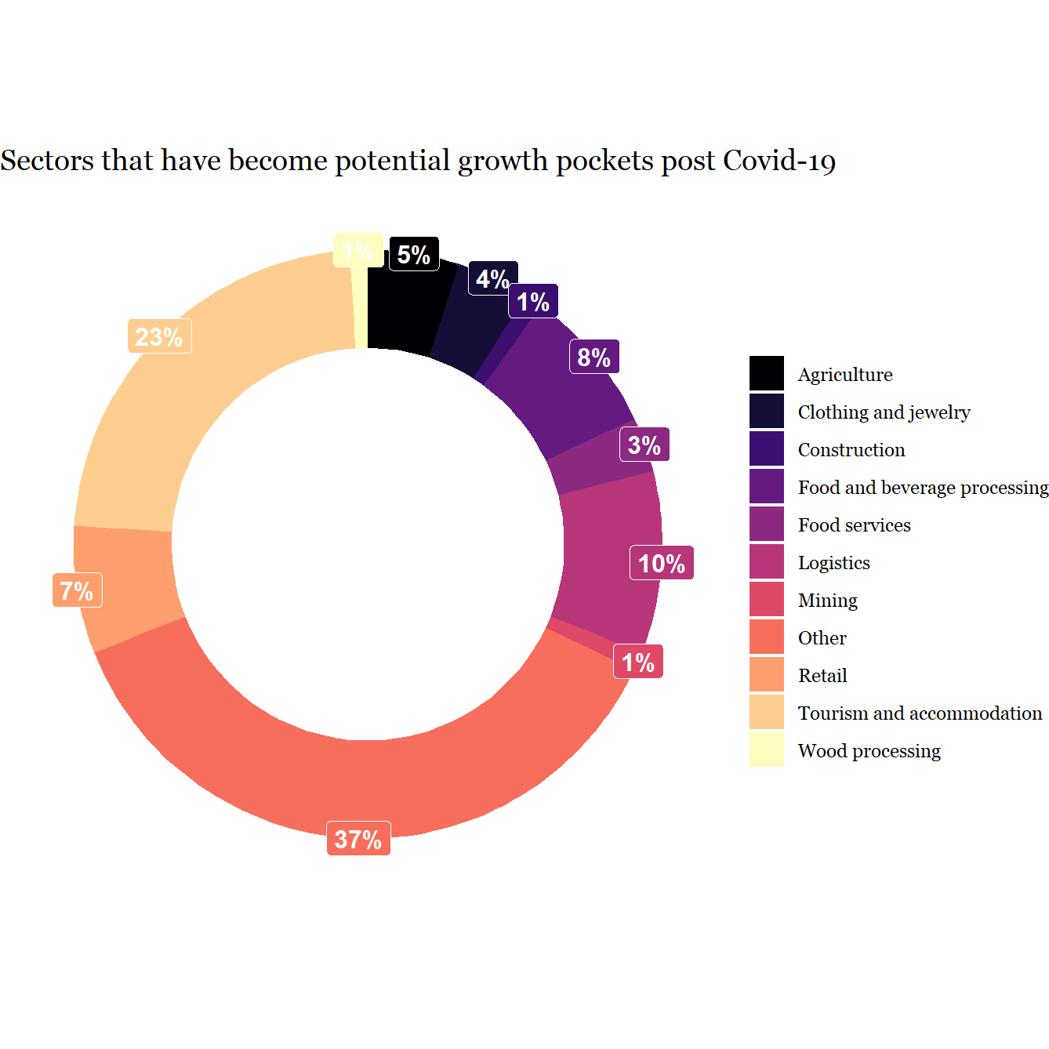
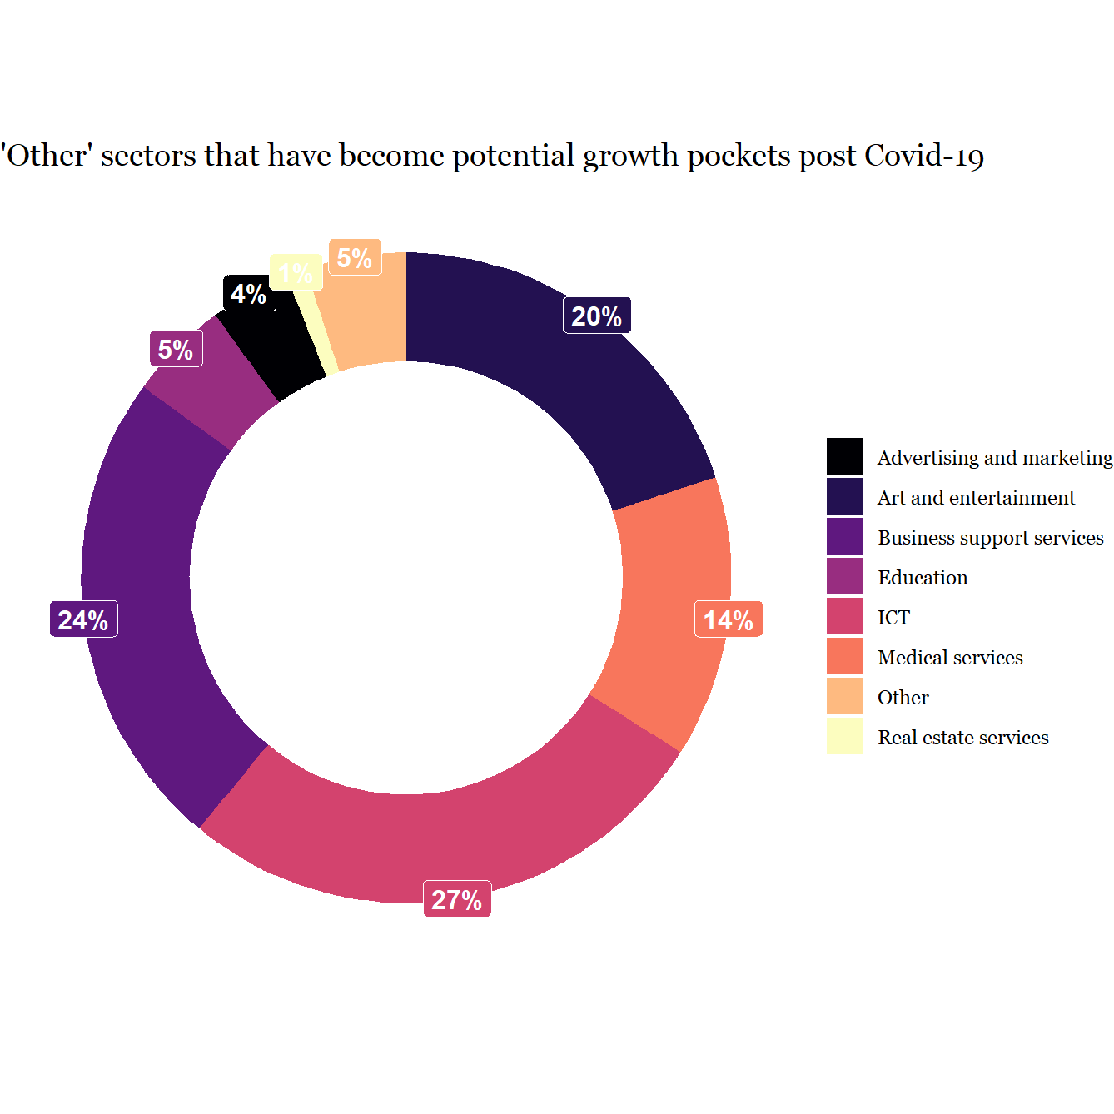
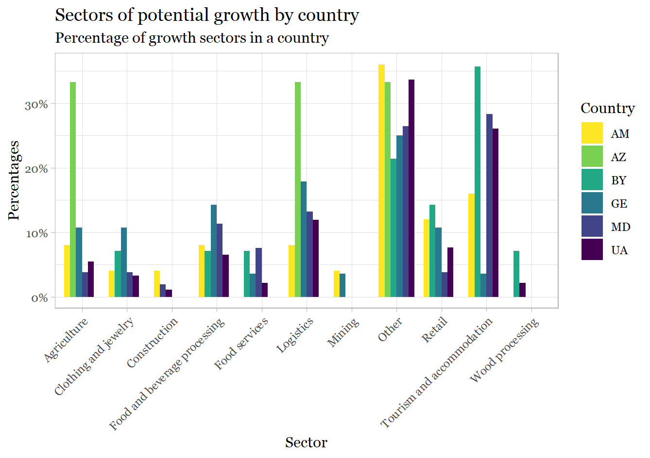

5. Priority sectors in need of support
We next asked LED Partnerships to identify three priority sectors that are in need of external support. They were asked to bear the following in mind when arriving at their answers.
- Can this sector do relatively well without much external support?
- Are there already available support measures from the government of international donors for this sector? Is that enough?
- What will be the cost of saving/losing this industry (sector)?
- Will earlier revival of this sector positively influence the revival of other sectors? Which sector has the biggest spillover potential? (Also think local clusters and value chains)?
- Can the sector re-profile and adjust to improve its resilience?
- Can this sector potentially absorb some of the excess labour power?
We first show how often certain sectors were mentioned as the highest priority areas for LED Partnerships by country. We then look at the sectors that were mentioned as either first, second, or third priority as percentages of all sectors that were mentioned as a priority in a given country.
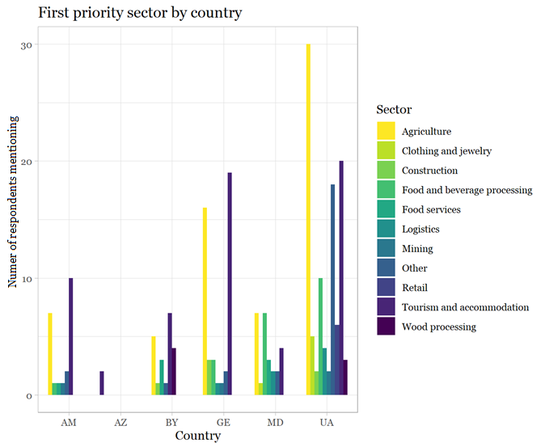
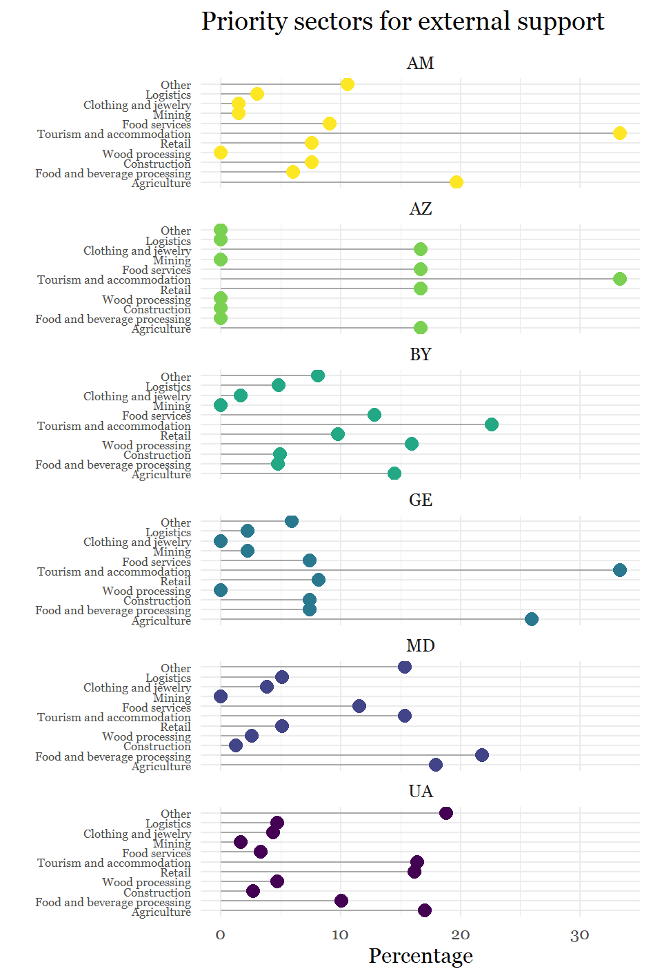
- Most generally, the two sectors that were among those most regularly identified as most important to the LED Partnerships – agriculture and tourism – remain the highest priority among the largest number of LED Partnerships.
- This is the case despite agriculture not being among the most heavily impacted sectors by Covid-19.
- This picture emerges prominently also when looking at the three highest priority sectors (the second figure), where about 30% of the times a sector is selected it is the tourism sector and about 17% the agricultural sector.
- Tourism is clearly the highest priority on average. Only in Moldova and Ukraine is agriculture slightly more often selected on average.
- There are other sectors that are mentioned as priorities in some countries
  - Clothing and jewellery in Azerbaijan
  - Retail in Azerbaijan and Ukraine
  - Food and beverages in Moldova
  - And in Ukraine ‘other’ sectors that we did not focus on, specifically machine and equipment manufacturing.
In short, the results point to the importance of local and national nuance about priorities. But those sectors that were deemed of greatest importance to the LED Partnerships before Covid-19 appear to remain the areas of greatest priority for ongoing external support.

6. Levels of optimism about the future of local economy
The final section considers responses to the question we asked each LED Partnership about the level of optimism they felt about the future of their local economy. Responses could range between very optimistic and very pessimistic. The results are shown in the figure below, which shows what percentage of the municipalities in a given country reported a certain level of optimism.

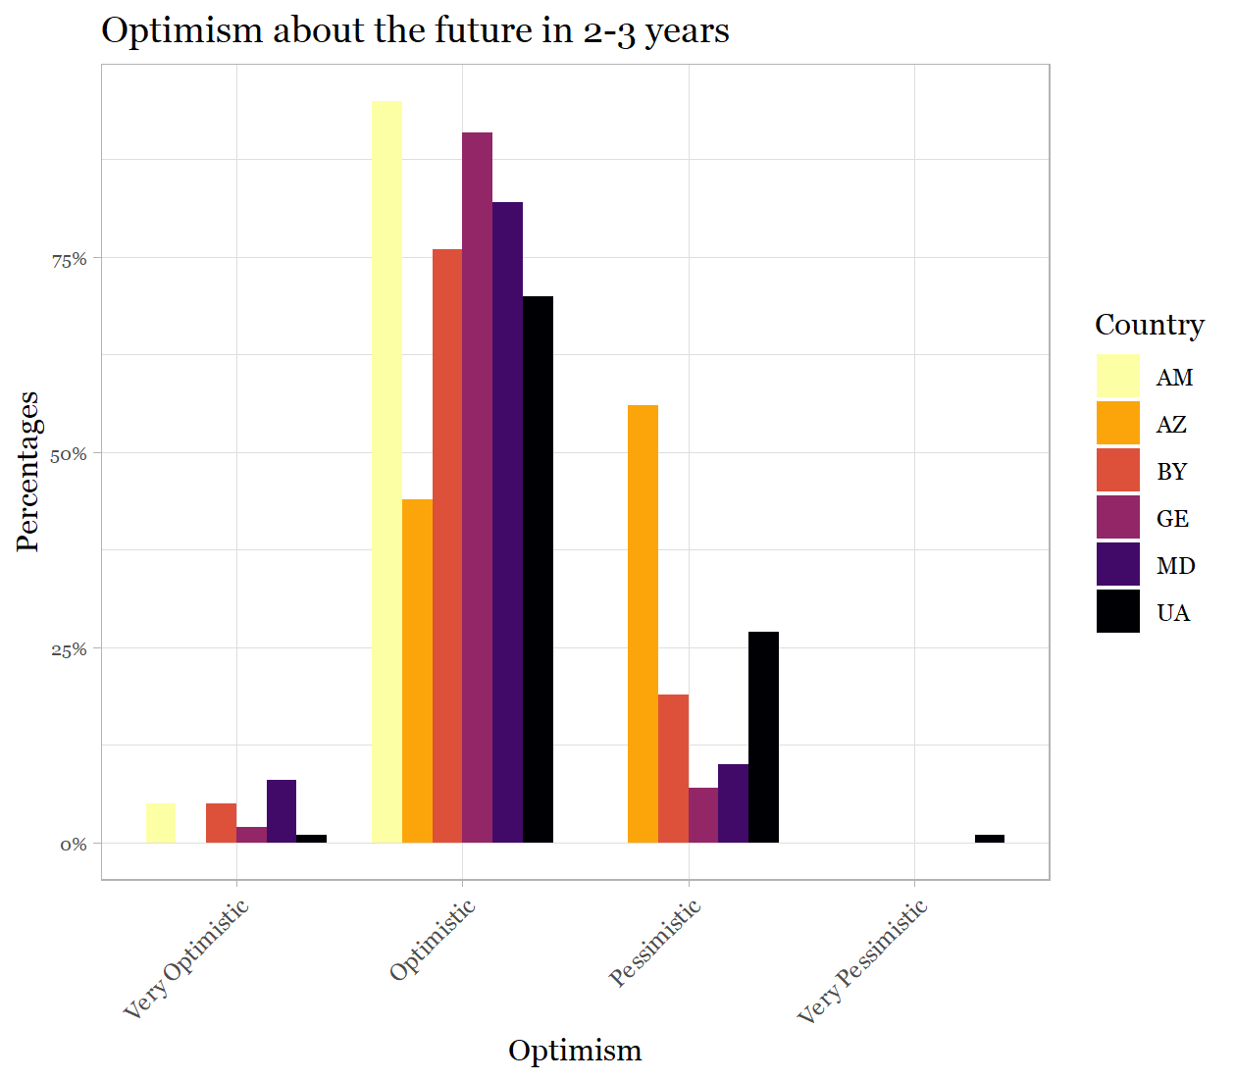

- Few are either very optimistic or very pessimistic.
- There is a clear preponderance of optimism over pessimism.
- Azerbaijan and Ukraine are least optimistic, Armenian and Georgia the most optimistic
- As in the discussion of expected impact of Covid-19 in the next 2-3 years, optimism is higher when the negative growth impact now is highest and when the municipal revenue impact is lowest.
- Optimism is highest in regions with high immigration and smaller population centres and less in urban and rural settings compared to mixed.

Appendix A. Findings for Armenia
Current impact
- Devastating impact on wood processing, tourism and accommodation and food services; agriculture and other sectors (medical services and ICT) less affected.
- Impact is much less felt on municipal revenue than on economic growth and employment, though the effect of covid-19 on food services has very negative effects across all three economic dimensions.
Expected future impact
- Much less negative view of future prospects including in sectors most devastated at present.
- Little variance across sectors except that ‘other sectors’ may play a future transformative positive role. Especially the medical sector is seen as likely to grow.
Future new pockets of growth
- Relatively few LED Partnerships identified potential future pockets of growth.
- Responses were very varied across sectors though a preponderance of answers highlighted the possibilities of retail and tourism and accommodation.
Priorities for external support
- Tourism and accommodation were overwhelmingly the area identified as in need of highest priority for external support, followed by agriculture.
Optimism
- Armenian LED Partnerships are clearly optimistic about the future.

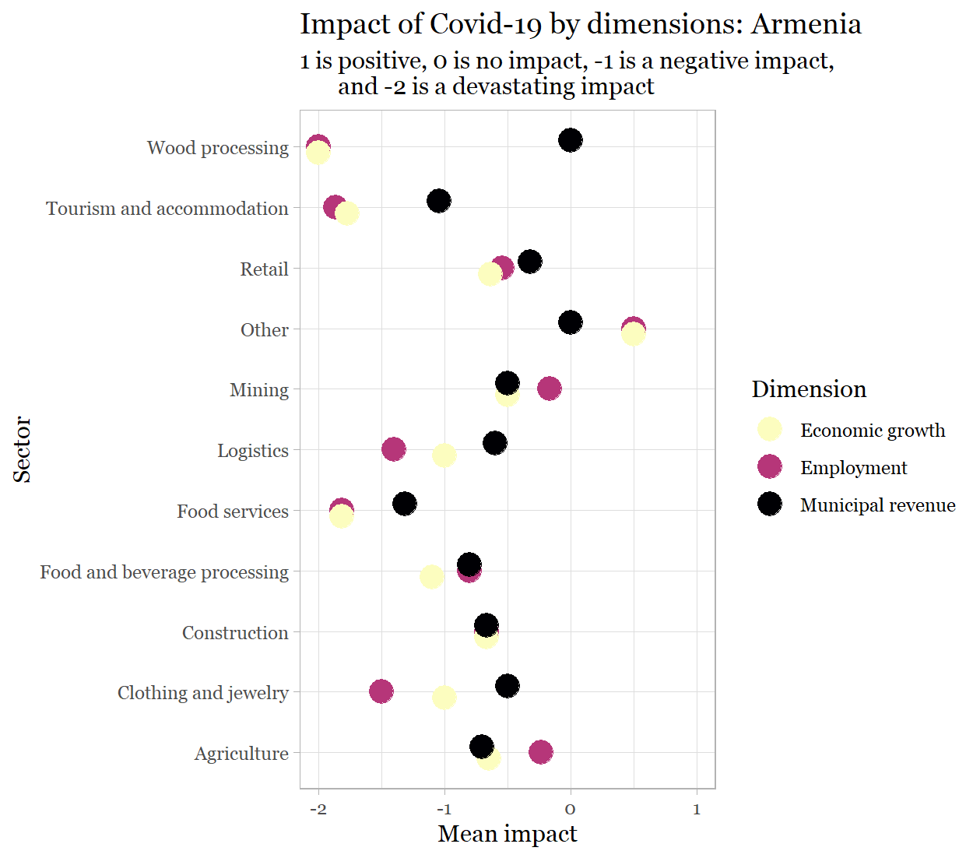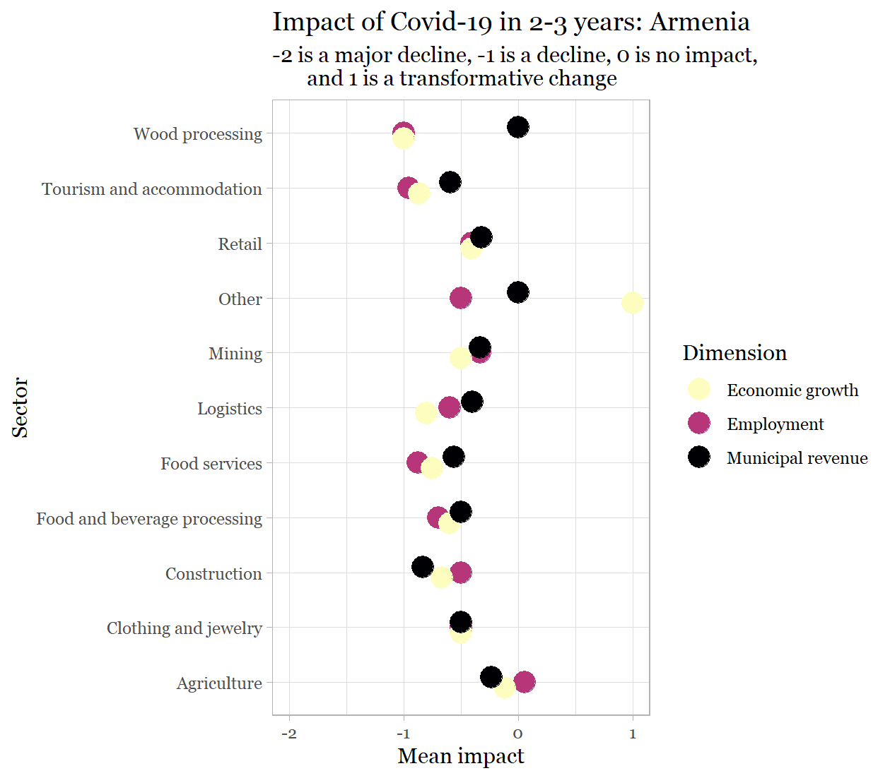

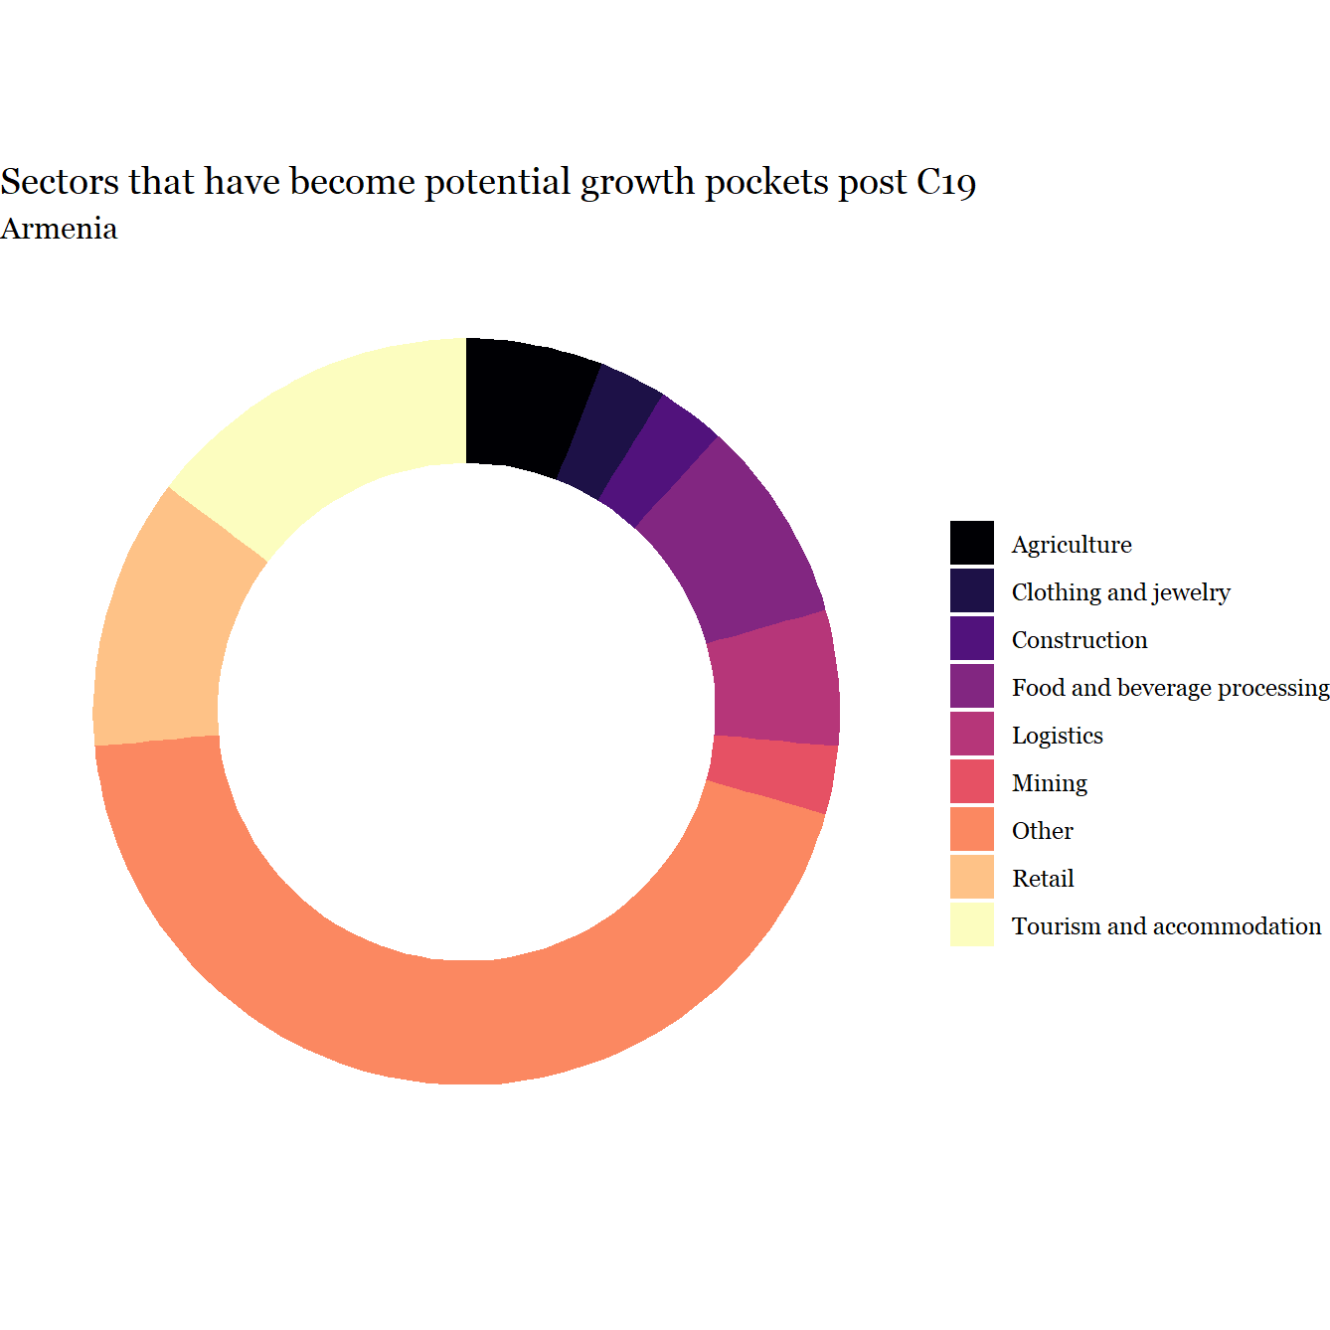

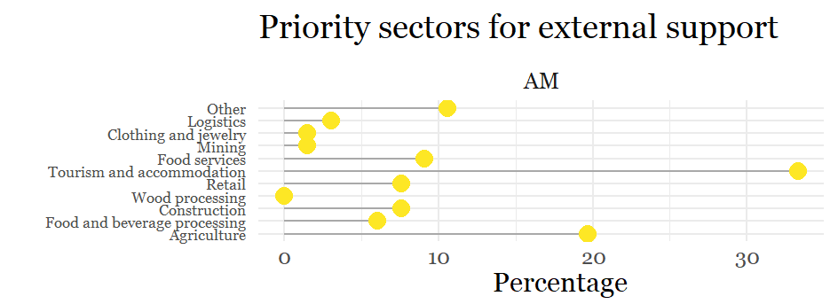

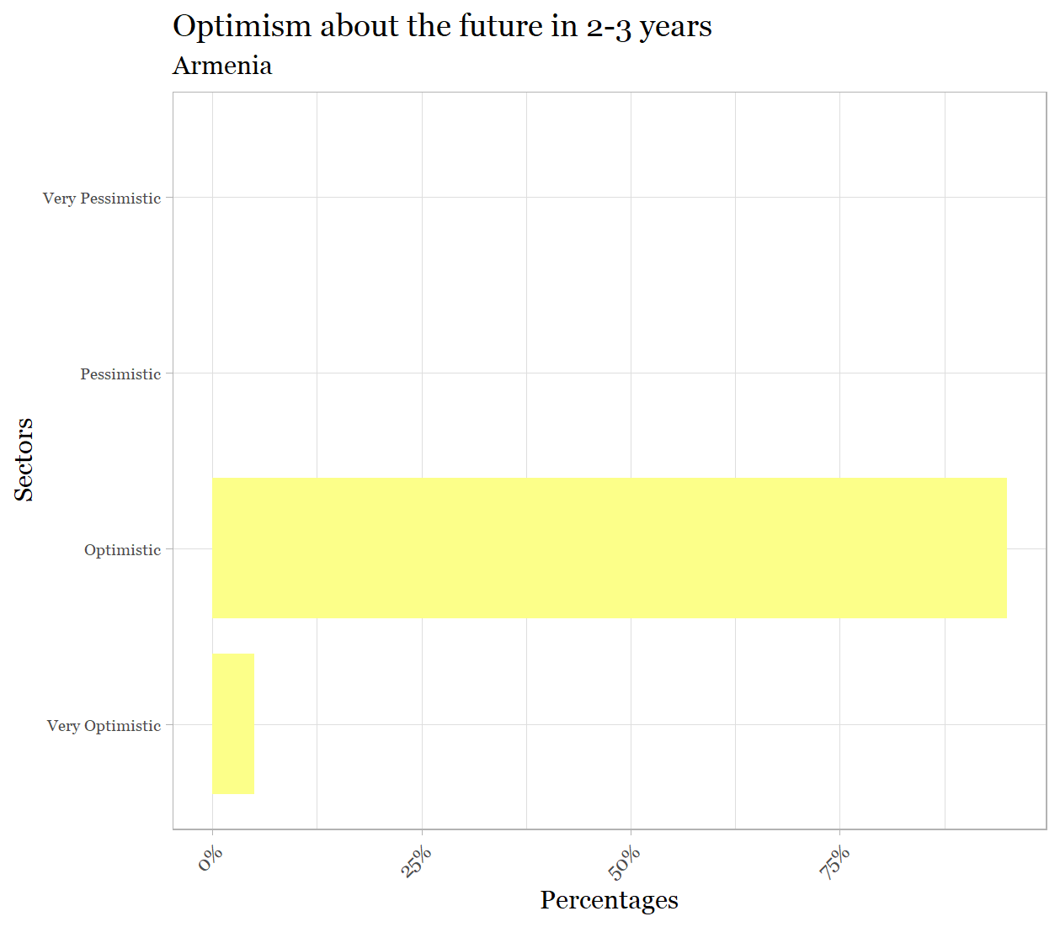

Appendix B. Findings for Azerbaijan. NB. Only 2 LED Partners so very limited sectoral representation
Current impact
- Devastating impact on tourism and accommodation and food services across all three economic dimensions.
Expected future impact
- Much less negative view of future prospects including in sectors most devastated at present.
- Food service and retail seen to have transformative possibilities.
Future new pockets of growth
- Responses were very varied across sectors though a preponderance of answers highlighted the future possibilities of logistics and agriculture.
Priorities for external support
- Tourism and accommodation were overwhelmingly the area identified as in need of highest priority for external support.
Optimism
- There is widespread pessimism among the Azerbaijani LED Partnerships.

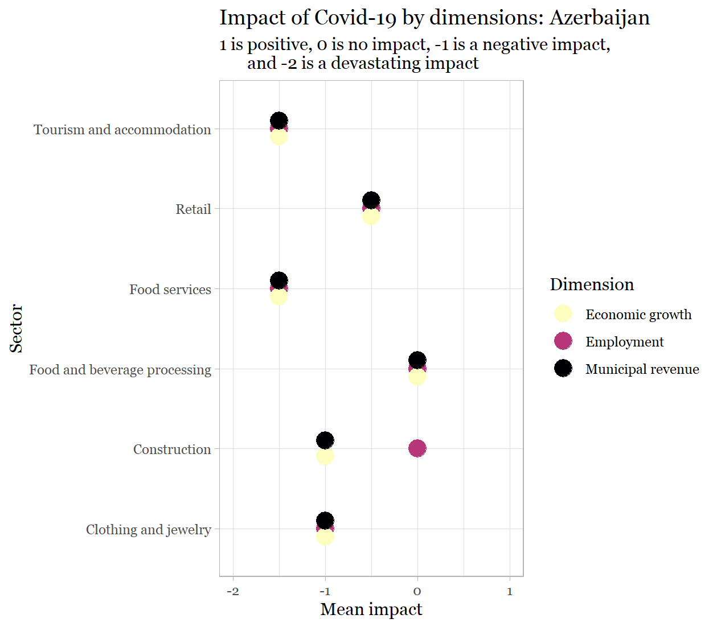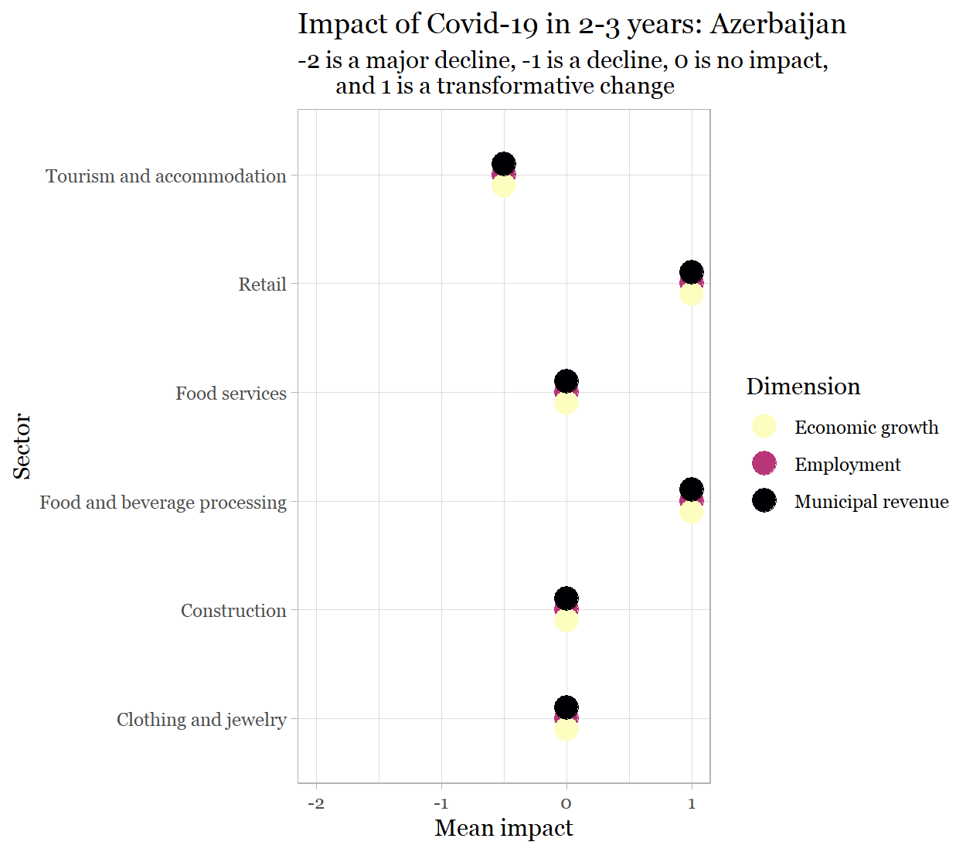

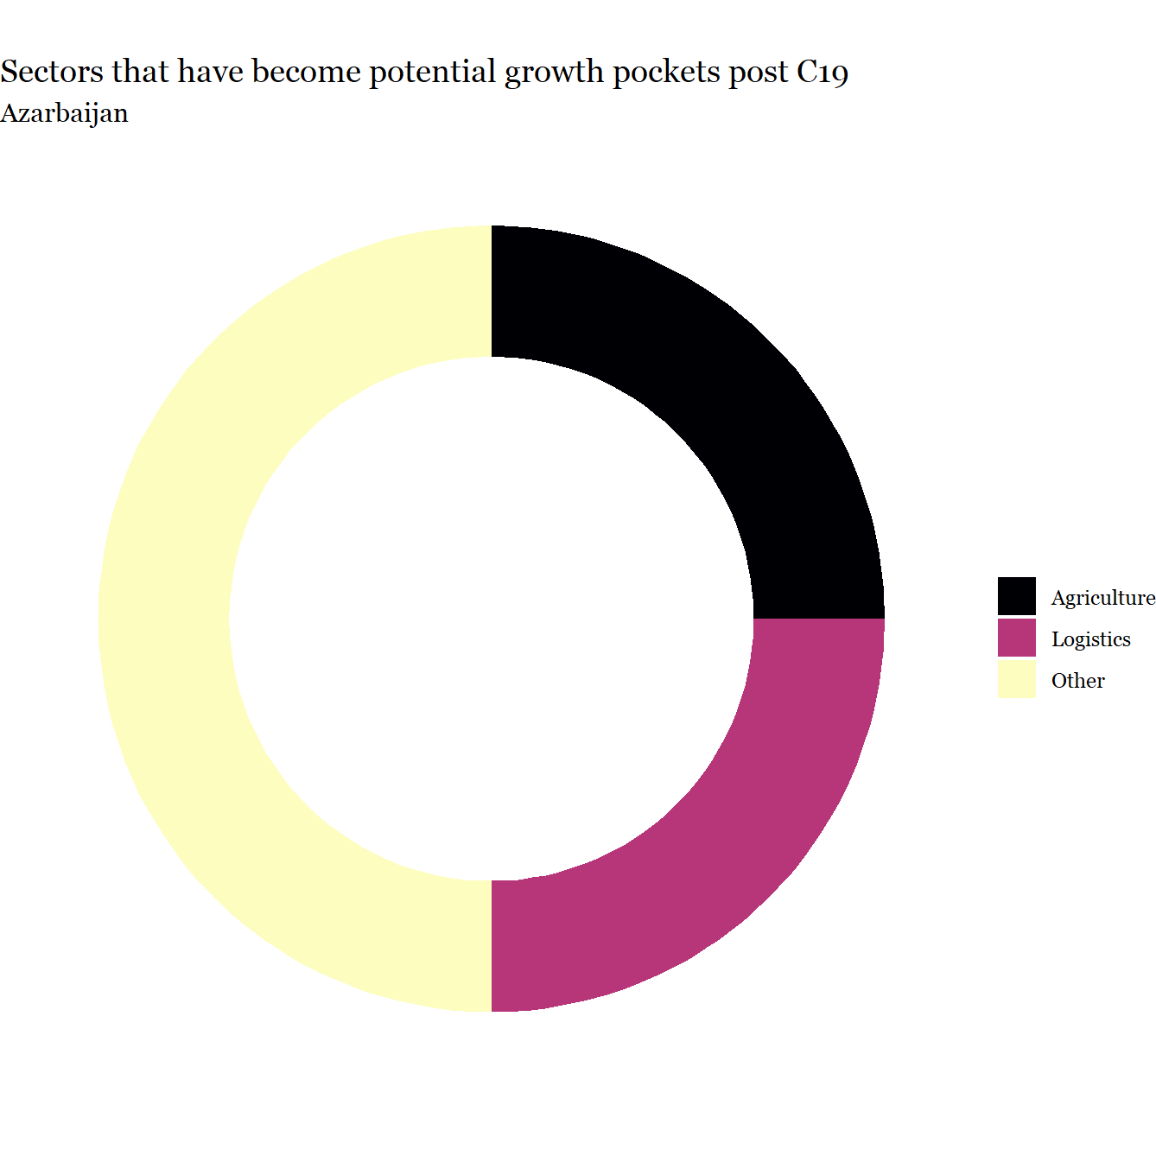

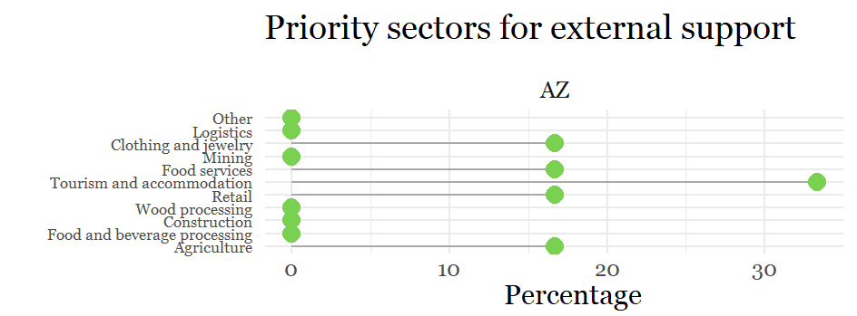

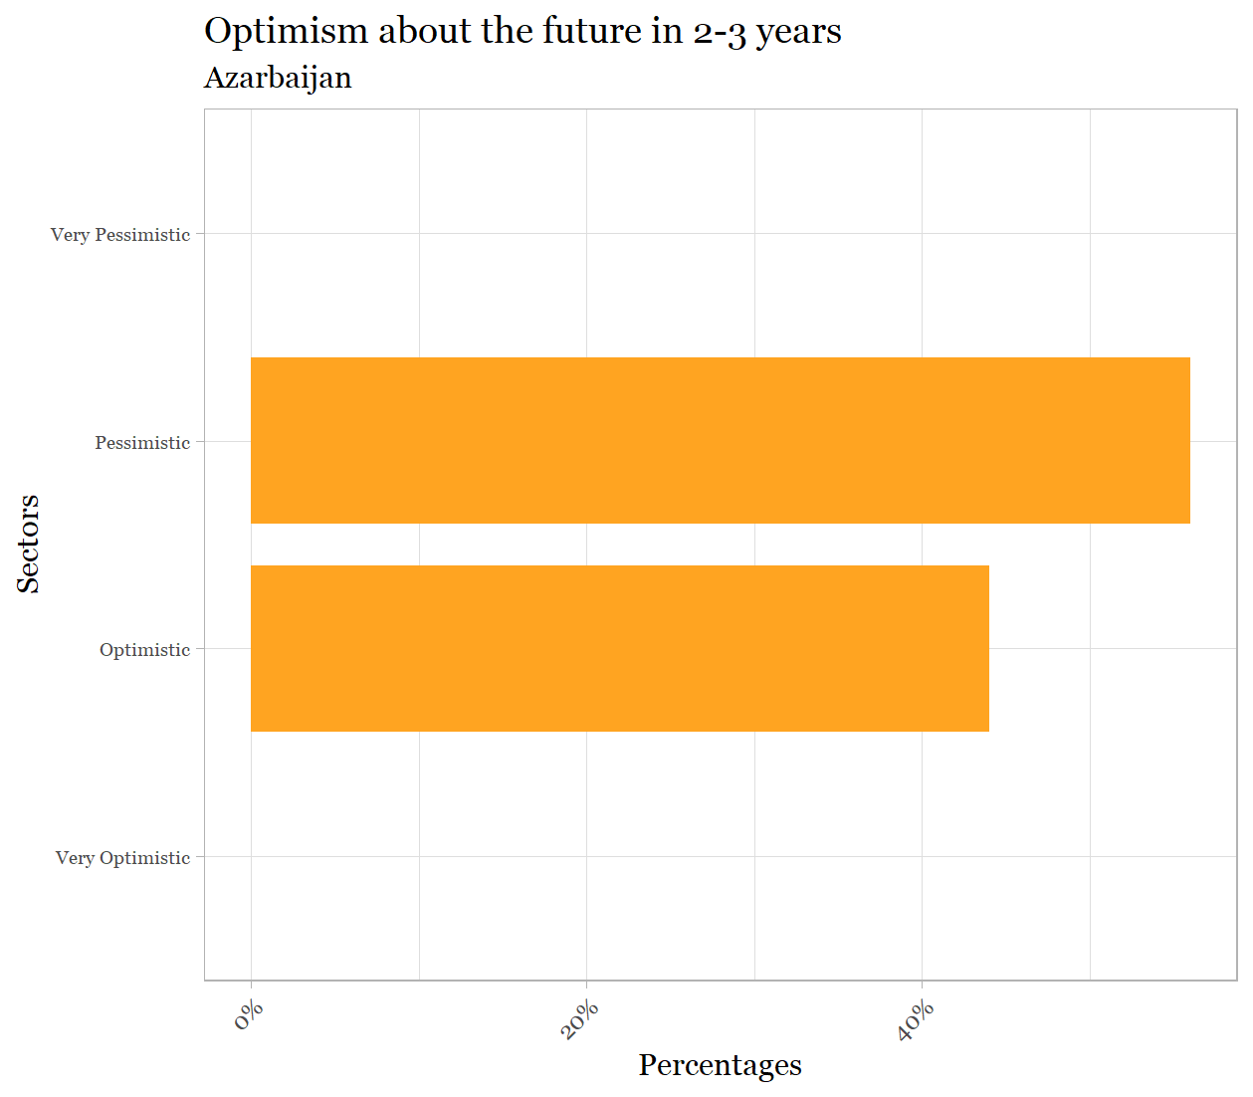

Appendix C. Findings for Belarus
Current impact
- Clearly negative impacts are felt, most strongly on economic growth in food services and tourism and accommodation, but not seen as devastating (most likely due to lack of restrictive measures imposed on economic activities in Belarus).
Expected future impact
- Much less negative view of future prospects including in sectors most devastated at present
Little variance across sectors, except that agriculture seems relatively unaffected.
- Relatively few LED Partnerships identified potential future pockets of growth.
- Responses were very varied across sectors though a preponderance of answers highlighted the possibilities of tourism and accommodation.
Priorities for external support
- Tourism and accommodation were overwhelmingly the area identified as in need of highest priority for external support, followed by wood processing.
Optimism
- LED Partnerships in Belarus are clearly more optimistic about the future than pessimistic with a small number expressing very optimistic views.

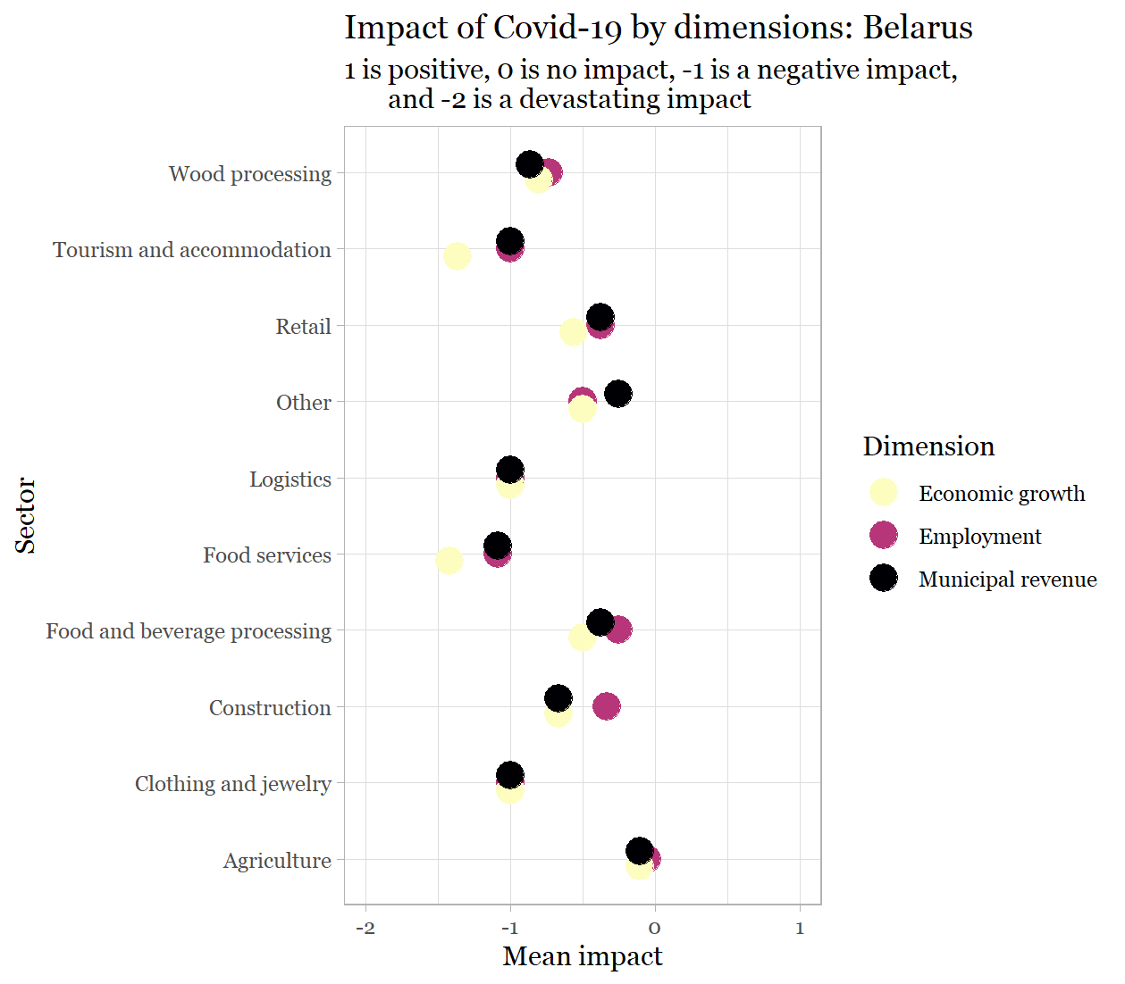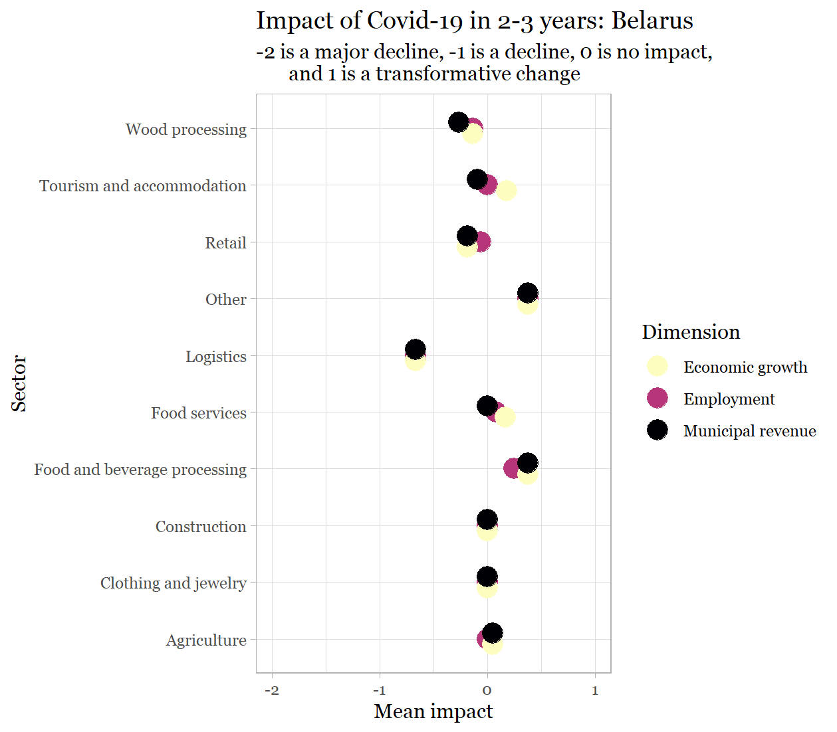

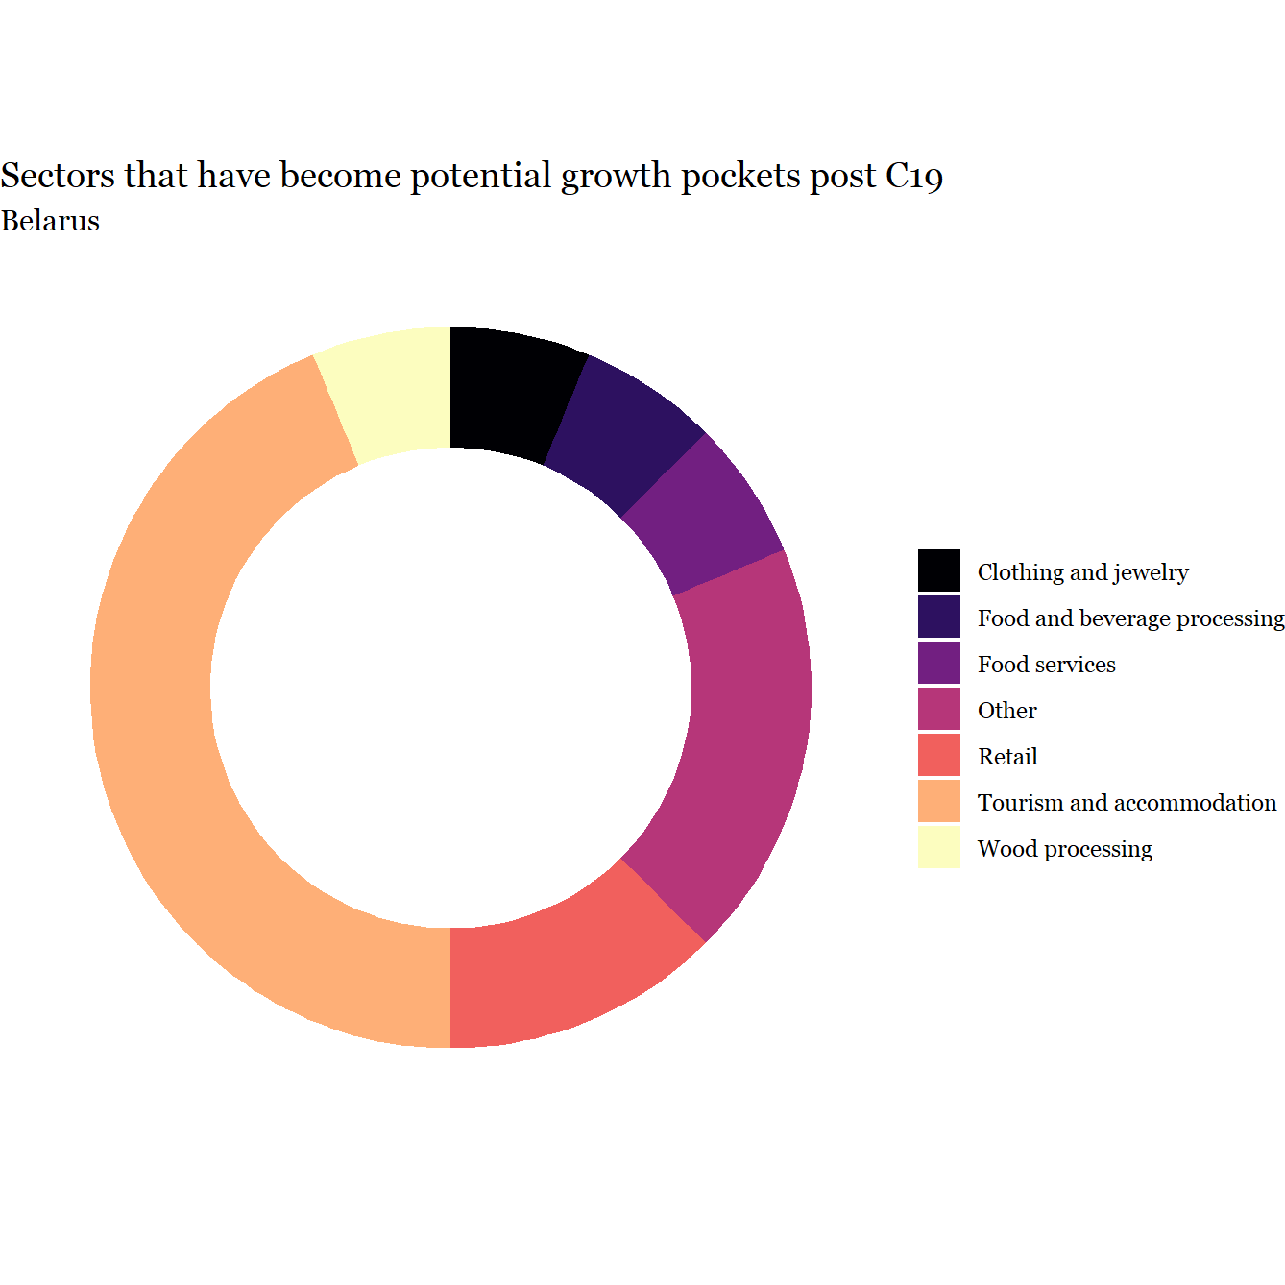

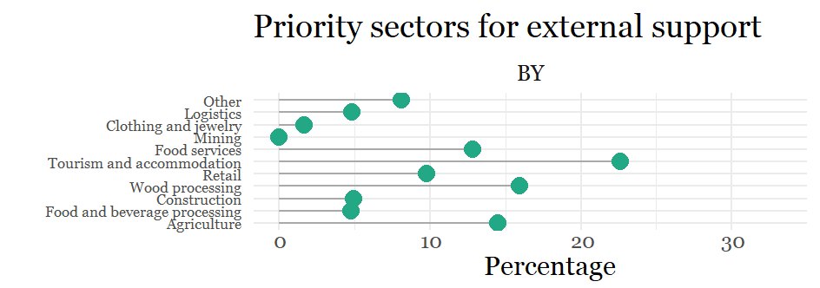

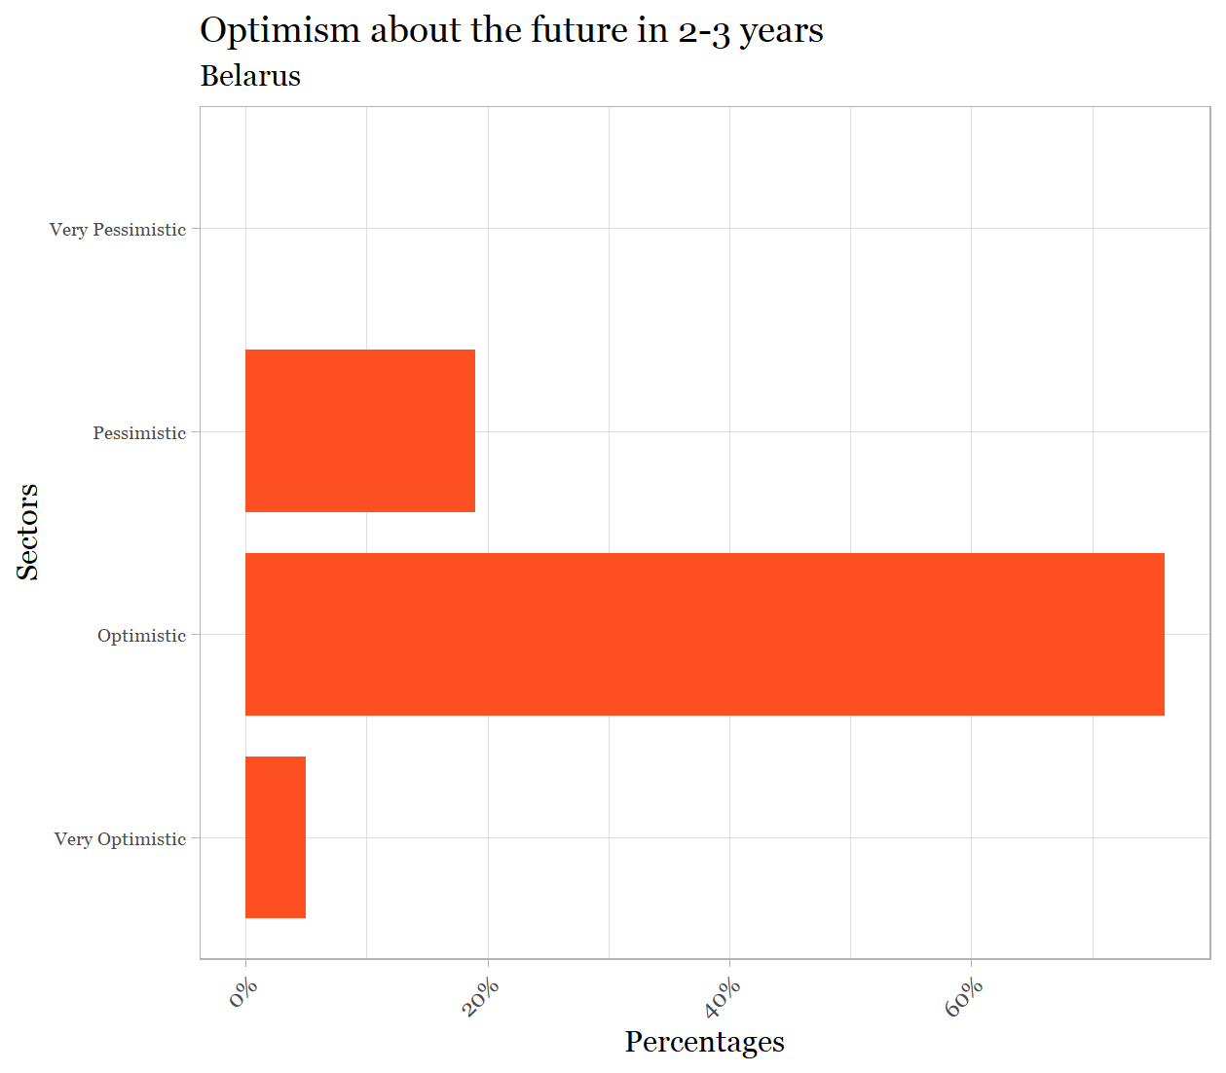

Appendix D. Findings for Georgia
Current impact
- Devastating impacts have been experienced in tourism and accommodation and in food services, particularly with regard to economic growth and employment, with strongly negative impacts across almost all sectors.
Expected future impact
- Much less negative view of future prospects including in sectors most devastated at present.
- Little variance across sectors but no sector is expected to play a transformative future role.
Future new pockets of growth
- Relatively few LED Partnerships identified potential future pockets of growth.
- Responses were very varied across sectors with a wide range of ‘other sectors’ not originally identified as important being mentioned; agriculture and logistics however stand out as possible areas for future growth.
Priorities for external support
- Tourism and accommodation and agriculture were overwhelmingly the areas identified as in need of highest priority for external support
Optimism
- LED Partnerships in Georgia s are clearly more optimistic about the future than pessimistic with a small number expressing very optimistic views

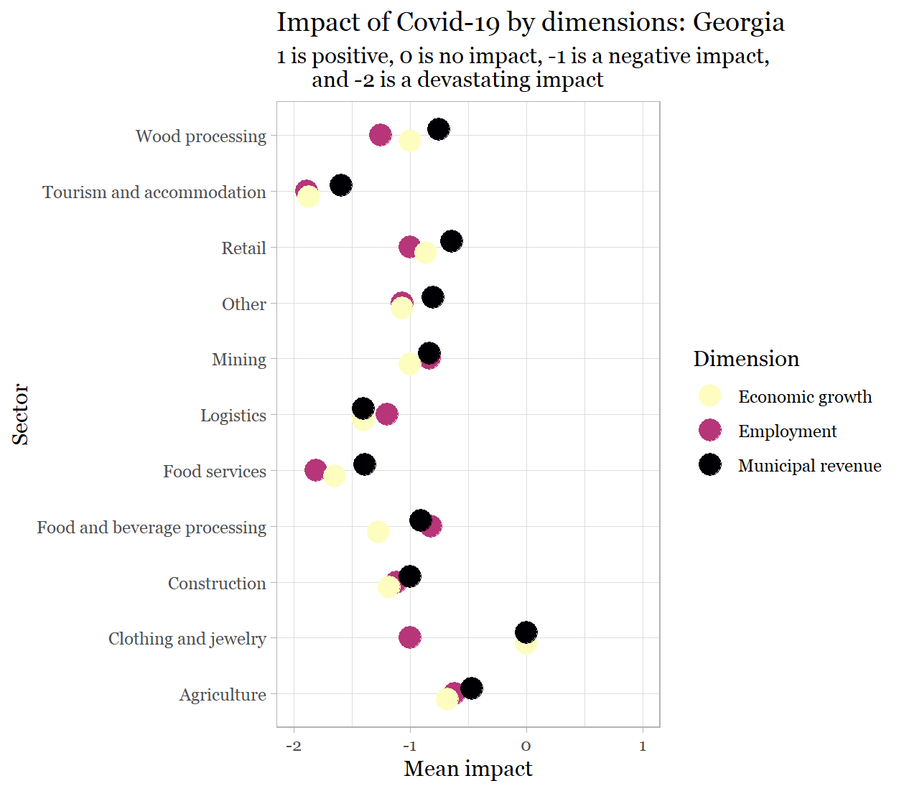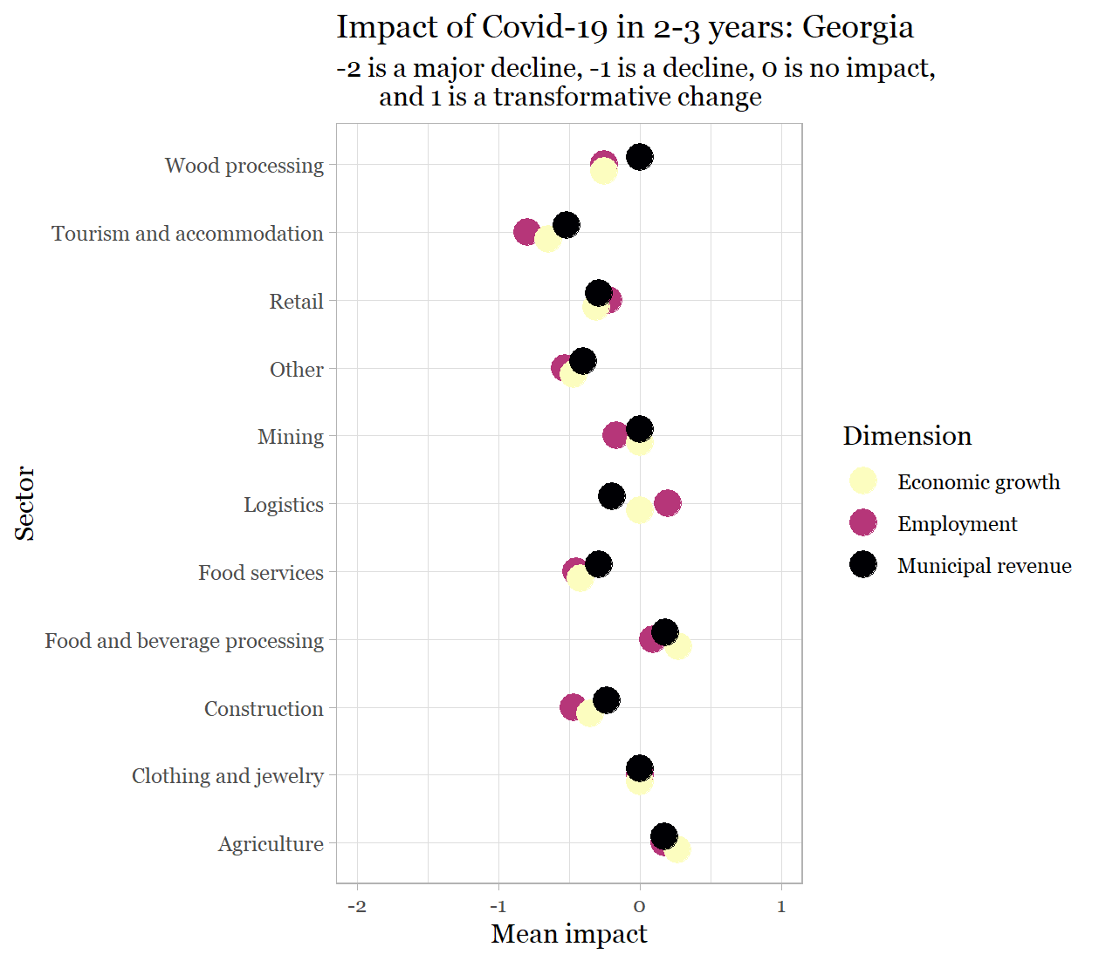

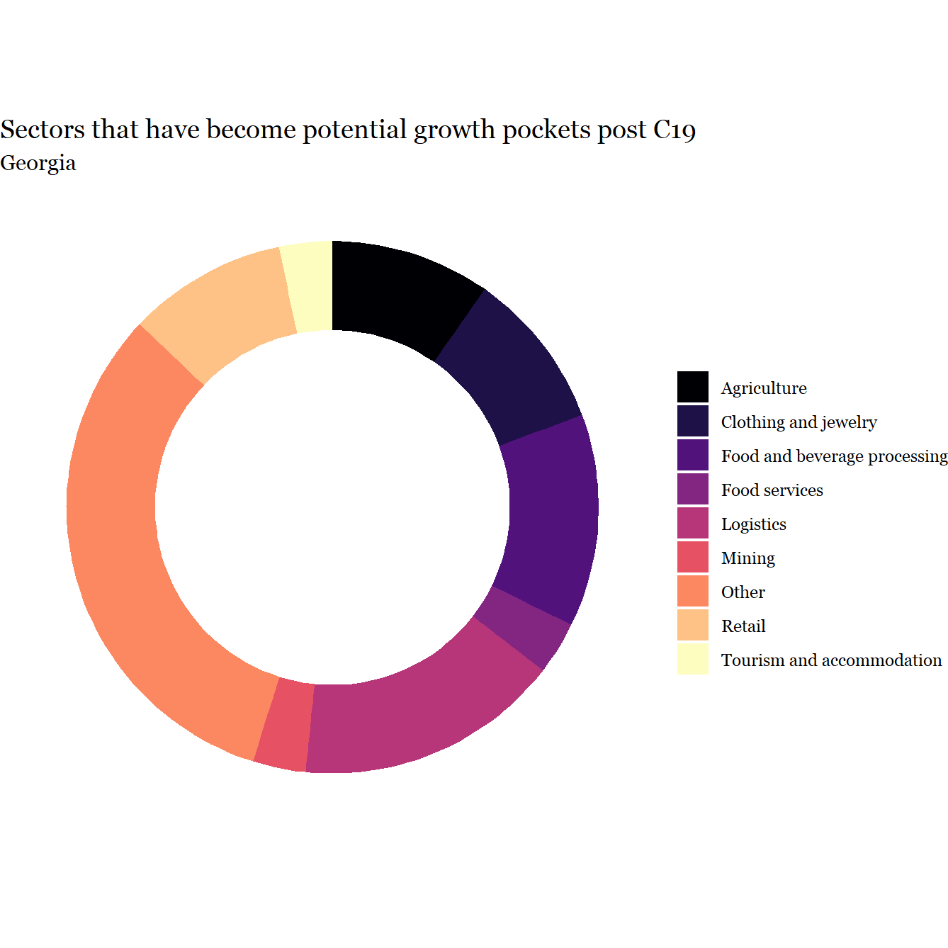

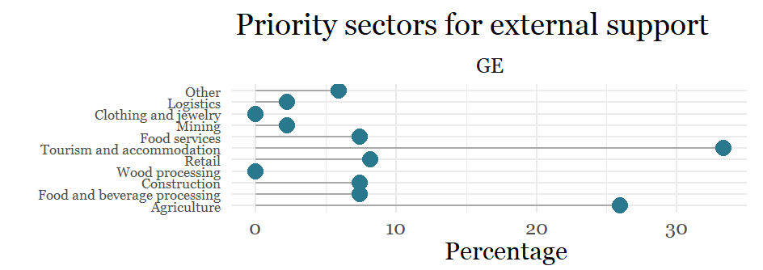

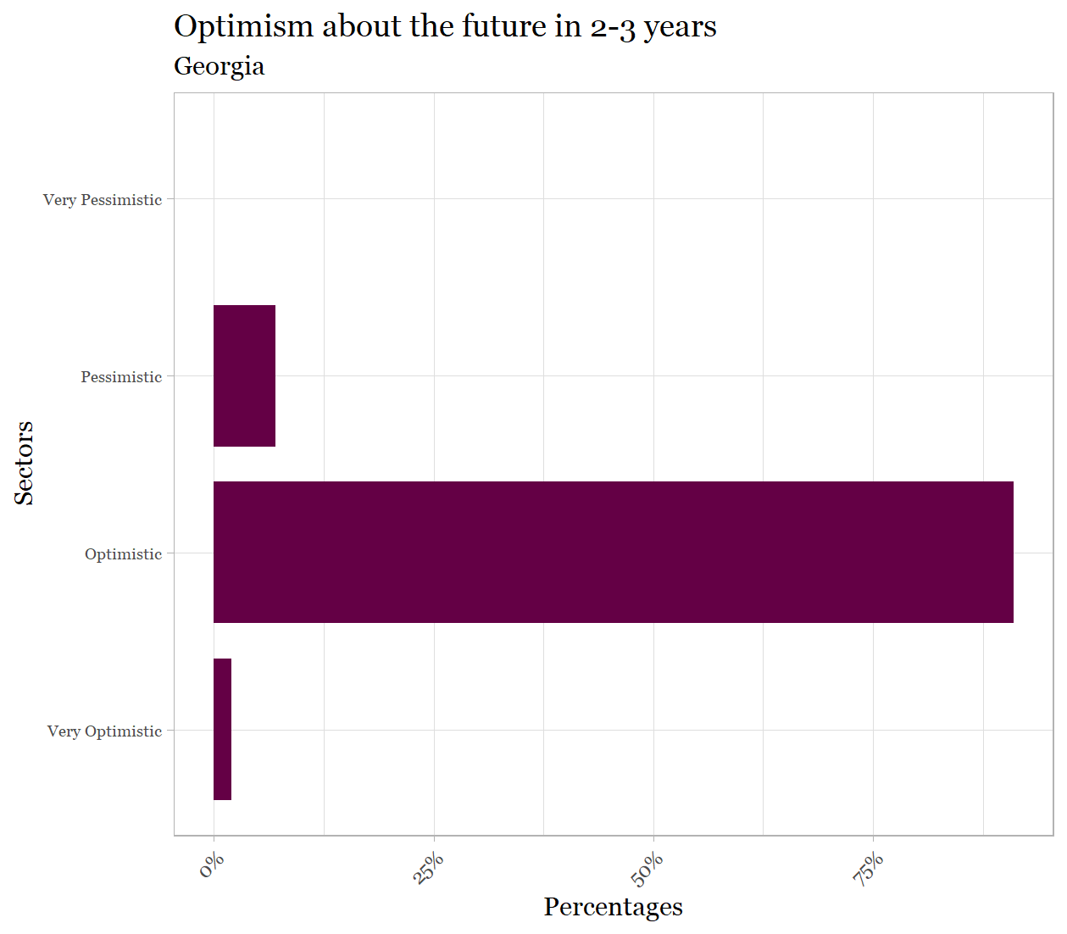
Appendix E. Findings for Moldova
Current impact
- Devastating impacts across a very broad range of sectors – tourism and accommodation, mining, logistics, food services – that affect growth, employment and municipal revenue.
- Construction seems the only sector that is not severely hit.
Expected future impact
- Much less negative view of future prospects including in sectors most devastated at present, with tourism and accommodation over the next three years seen as a potentially strong positive sector.
- Implications of Covid-19 for municipal revenue over the next three years is notably negative compared to employment and growth.
Future new pockets of growth
- Relatively few LED Partners identified potential future pockets.
- Responses were very varied across sectors with a wide range of ‘other sectors’ not originally identified as important being mentioned; tourism and accommodation however stands out as a possible area for future growth.
Priorities for external support
- Food and beverage processing, tourism and accommodation, and agriculture were the areas identified as in need of highest priority for external support.
Optimism
- LED Partnerships in Moldova are clearly more optimistic about the future than pessimistic with a small number expressing very optimistic views

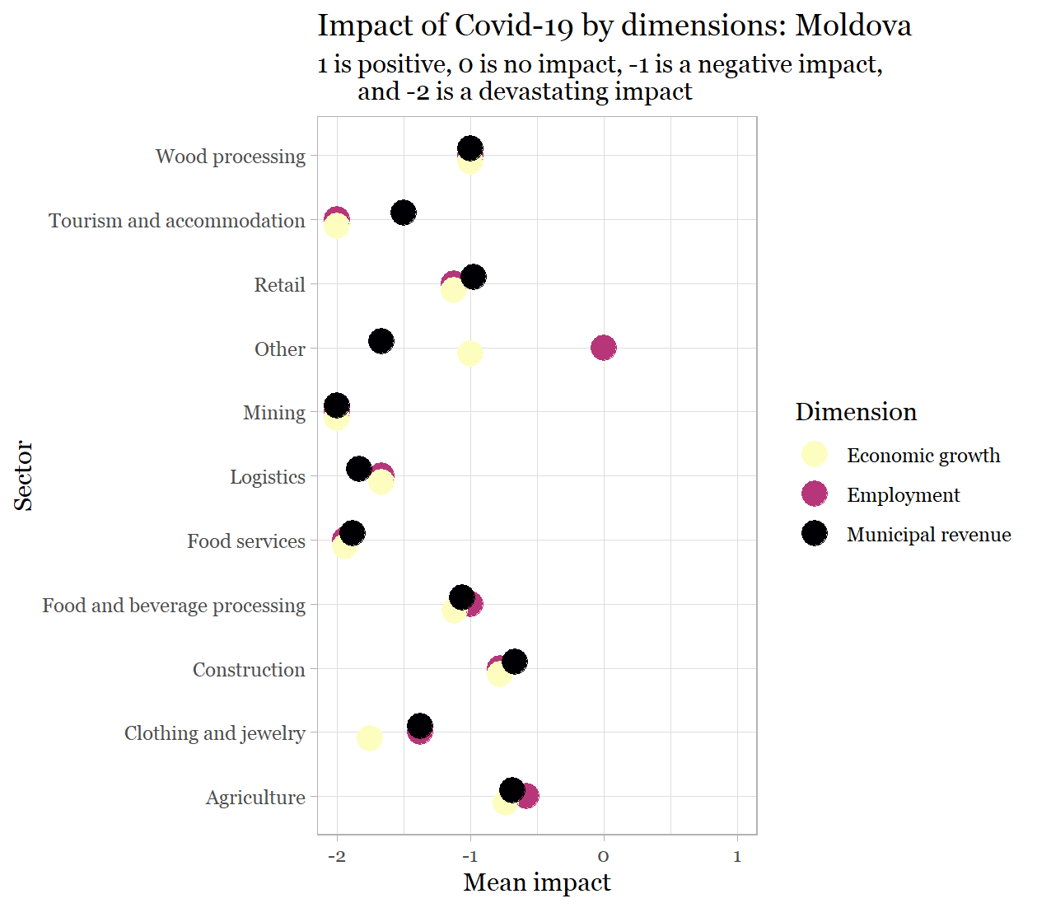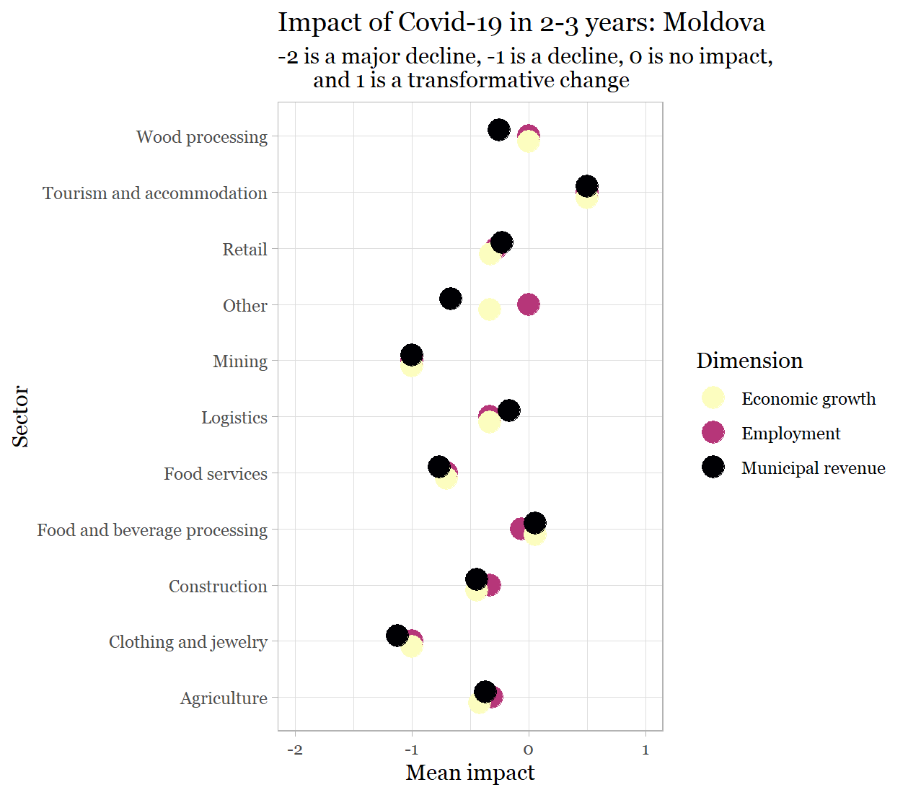

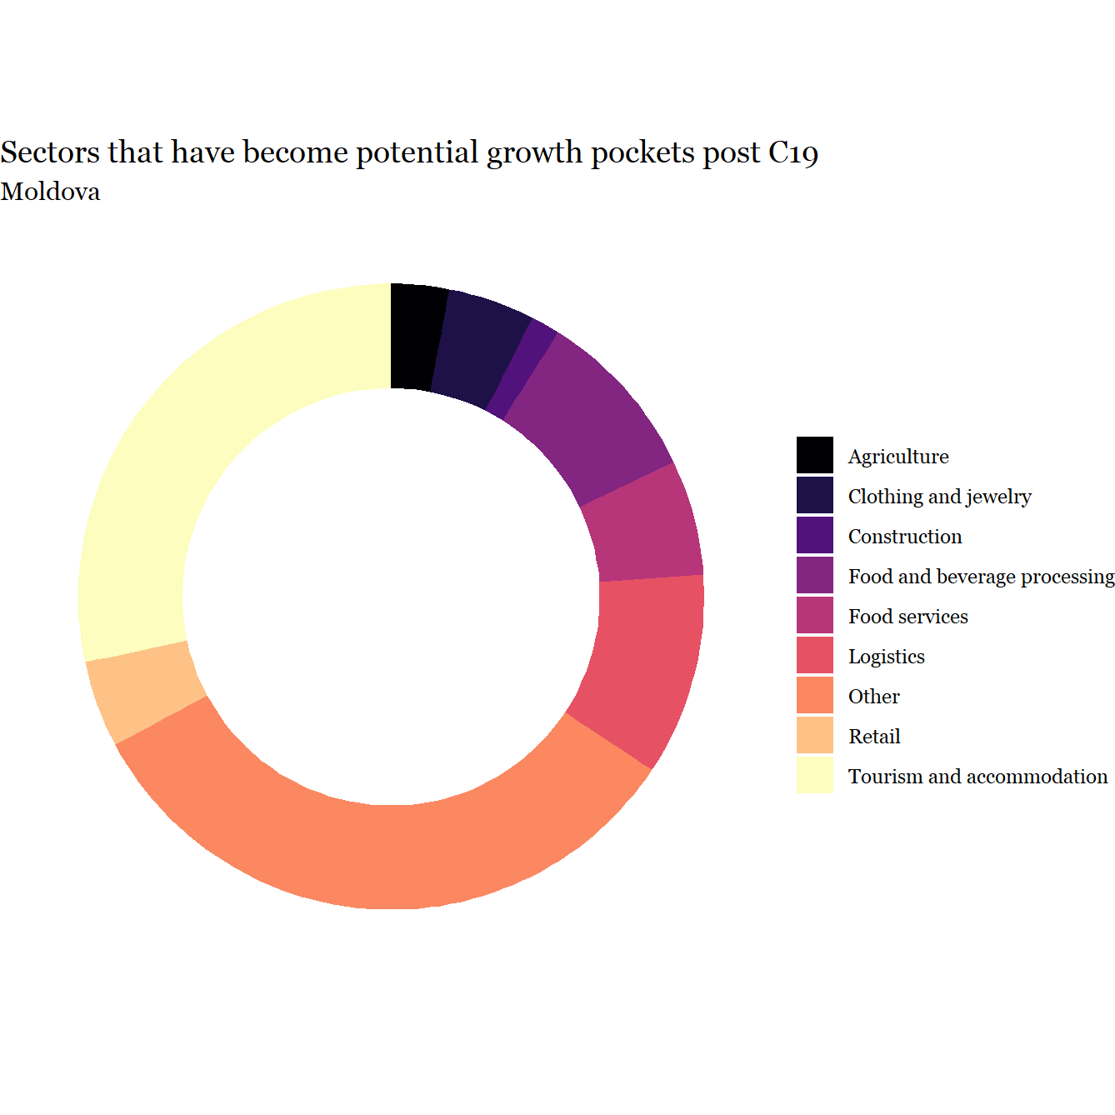

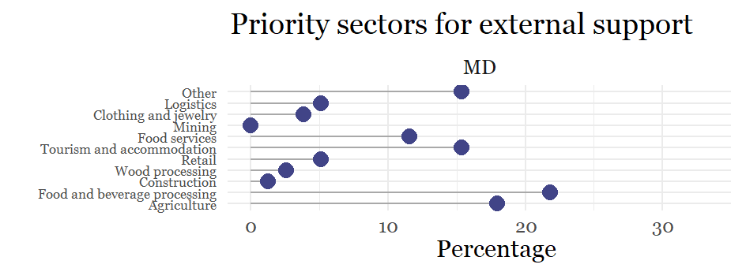

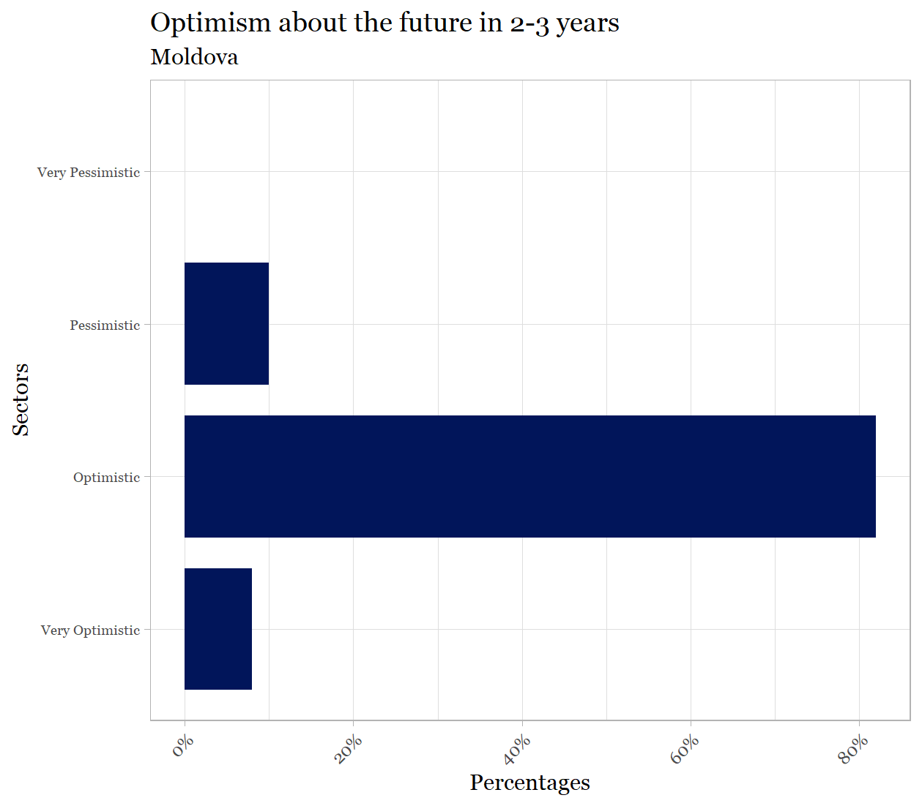

Appendix F. Findings for Ukraine
Current impact
- Devastating impacts across a very broad range of sectors – tourism and accommodation, logistics, food services – that affect growth, employment and municipal revenue.
- No sector in Ukraine has not been negatively affected.
Expected future impact
- Much less negative view of future prospects including in sectors most devastated at present, though slightly negative expectations are still widely prevalent.
- No areas are expected to strongly rebound over the next three years.
Future new pockets of growth
- Relatively few LED Partnerships identified potential future pockets of growth.
- Responses were very varied across sectors with a wide range of ‘other sectors’ not originally identified as important being mentioned. Specifically Art and entertainment, Business support services, Medical services, and ICT.
- Tourism and accommodation also stand out as a possible area for future growth.
Priorities for external support
- As a large economy with 100 LED Partnerships, not surprisingly there is a wide range of views on priorities for external support
- Travel and accommodation, agriculture and retail predominate, along with a very broad range of other choices with no single one standing out
Optimism
- LED Partnerships in Ukraine are clearly more optimistic about the future than pessimistic with a small number expressing very optimistic views; but again befitting a large country with many Partnerships, there are many pessimistic and some strongly pessimistic views.

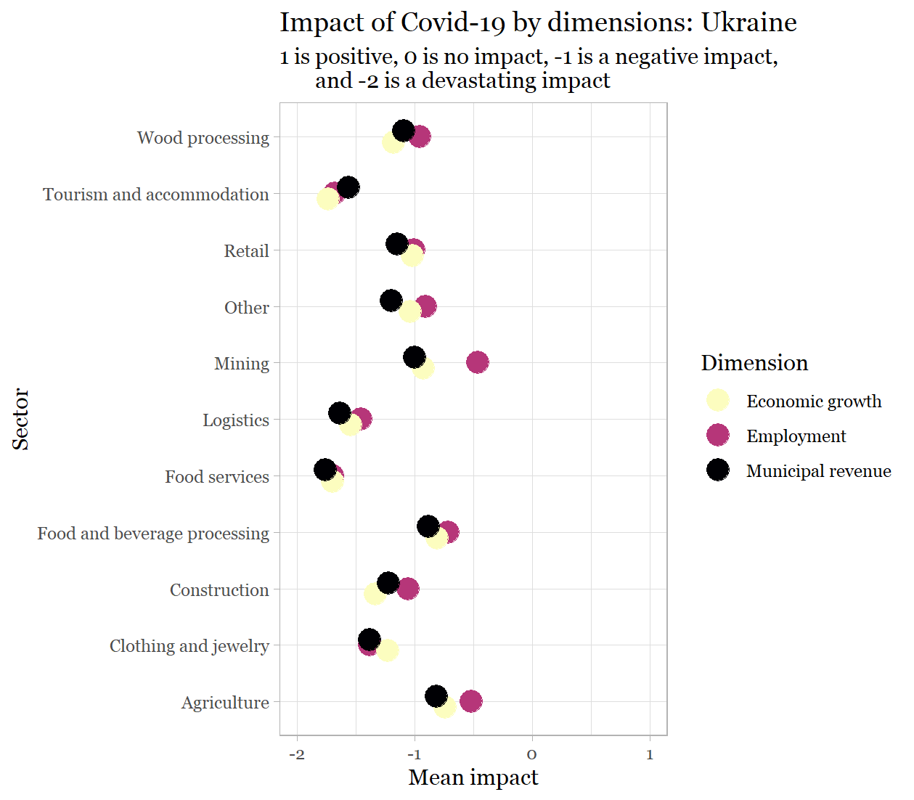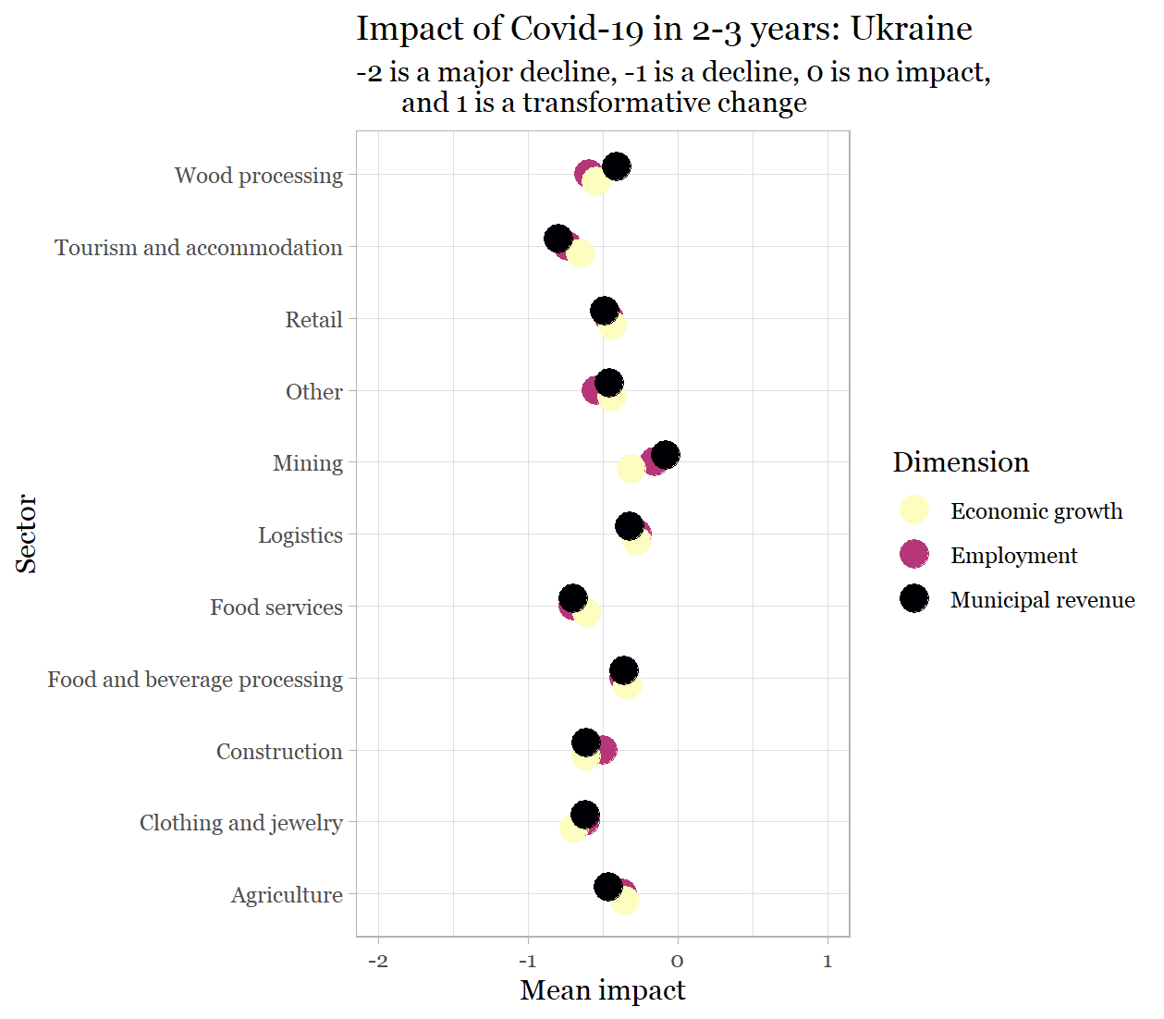

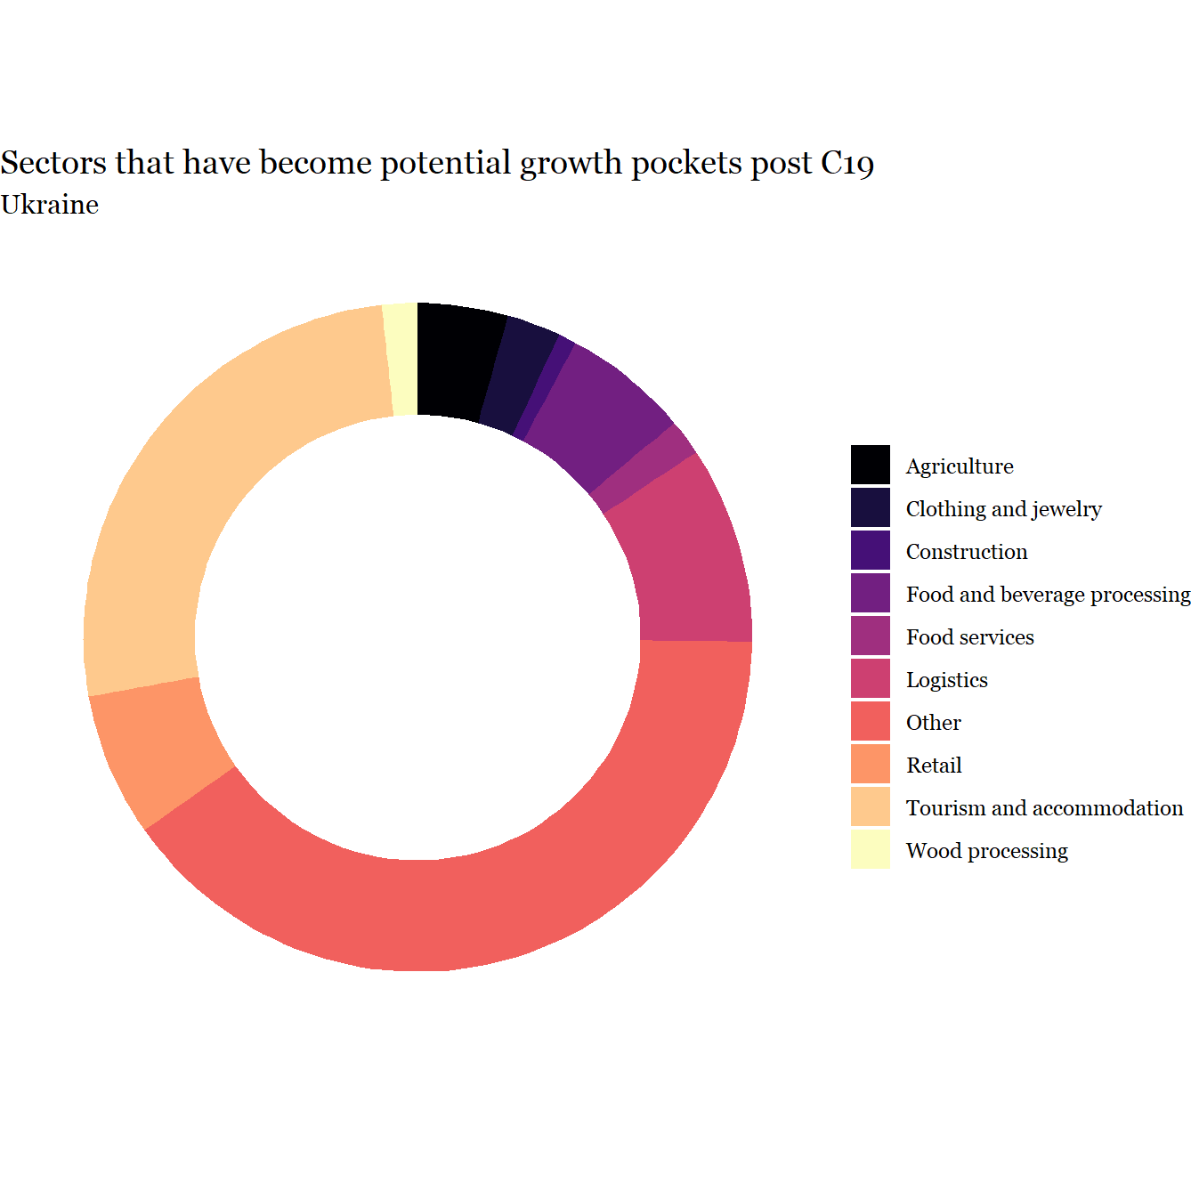

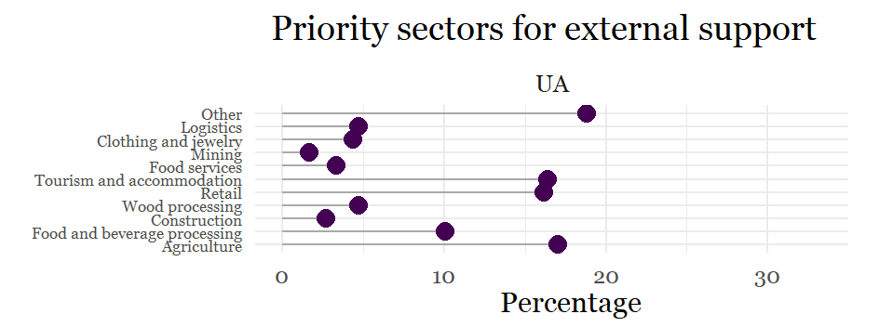

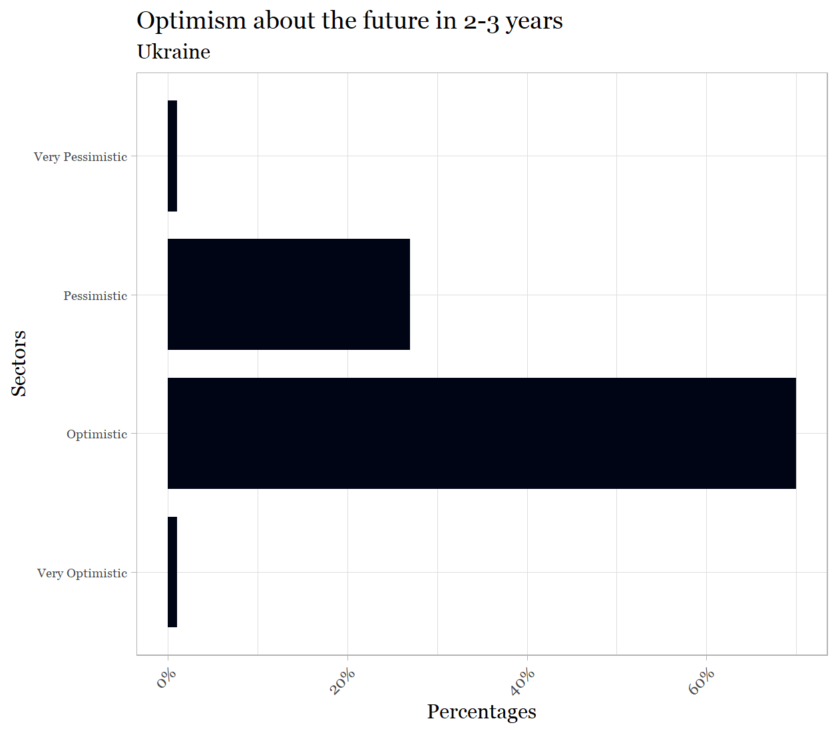

Appendix G: Explanation of the survey to Local Economic Development Partnerships
Dear Partner,
We are very grateful for your input into the survey designed to achieve the information discussed in the overview above. There are 9 batteries of questions. Answering them will take some time and consideration on your part. It is very important that you arrive at your judgements about each issue and sector through discussion with each stakeholder in your Local Economic Development Partnership. We are aware that some of your judgements will contain a degree of uncertainty. The more that you are able to find a consensus among all stakeholders the more reliable your responses will be. We are interested to know your most informed evaluations of the current situation.
Attached to these instructions, you will find the questionnaire which we ask you to fill out. Please read the instructions below carefully for each of the questions, and then fill out the attached questionnaire.

STARTING POINT - CHOOSE SECTORS.
From the list of economic sectors (attached), please select UP TO FIVE sectors that are important in your municipality. Please only choose sectors that are PRESENT in your municipality and are IMPORTANT. Please write down the numbers and names of these sectors, you will need them for question 1 to 5.
In questions 1 to 3, you are asked to answer some questions about the sectors you have selected. For each one of these questions, we need you to first write down the sectors you have selected. Afterwards, you can answer the questions. See below for an example of what to do for questions 1 to 3.
Sector No. and Title | Q1A.  Importance for employment | Q1B.  Importance for economic growth | Q1C.  Importance for local municipal revenue | Q1D.  Importance to your LED Partnership
6 Wood processing
10 Retail - food
14 Tourism
1 Agriculture
2 Food processing

Where you will answer the questions about each sector
The up to five important sectors with corresponding numbers you chose.

Survey

Q1. After writing down the numbers corresponding to the sectors (as described above), please indicate how important each sector used to be before the COVID-19 outbreak.
Your answers for each question should reflect the following considerations:
- importance for employment – how much did the sector contribute to employment in your locality?
- importance for economic growth – how much did the sector contribute to economic growth in your locality?
- importance for local municipal revenue – how much did the sector contribute to the local municipal revenue?
- importance to your LED Partnership – how much did you rely on the sector to realize your LED goals?

1 = Very important, 2 = important, 3 = minor importance, 4 = no importance.
In each cell enter the number that responds to how important the sector was.
Sector No. and Title | Q1A.  Importance for employment | Q1B.  Importance for economic growth | Q1C.  Importance for local municipal revenue | Q1D.  Importance to your LED Partnership

Q2. After once again writing down the number of the sectors you selected at the start, please indicate the degree to which each sector has been impacted to date by the COVID-19 outbreak and the restrictive measures introduced to fight it.
- = No significant impact – this would be the case if the sector’s operations currently continue to the same scale.
- = Significant negative impact – this would be the case if the COVID-19 epidemic has made a clear difference but activities are currently continuing without large scale disruption.
- = Major negative impact – this would be the case if the COVID-19 epidemic and the related restrictive measures have reduced activities to a dangerous degree.
- = Devastating impact – this would be the case if the COVID-19 epidemic and the related restrictive measures have stopped activities more or less entirely.
- = Positive impact - this would be the case if the COVID-19 epidemic and the related restrictive measures resulted in the sector’s growth.
In each cell enter the number that responds to how impacted each sector was.
Sector No. and Title | Q2A.  Impact on employment | Q2B.  Impact on economic growth | Q2C.  Impact on local municipal revenue

Q3. Again, using the economic sectors you chose earlier, please indicate what kind of change you would expect in each sector over the next 2-3 years in terms of revenue, jobs, and growth, compared to what it used to be before the pandemic (which you already assessed in Q1).
- = Major decline – this would be the case if the sector’s performance could be expected to fall significantly behind the level before COVID-19
- = Notable downturn – this would be the case if the sector’s performance is expected to be somewhat lower than before COVID-19
- = No significant change – the sector’s performance cam be expected approximately the same as before COVID-19
- = Transformative – this would be the case if the sector’s performance can be expected to be better than before COVID-19
In each cell enter a digit corresponding to the type and degree of change to be expected for the sector.
Sector No. and Title | Q3A.  Changes in employment | Q3B.  Dynamics in economic growth | Q3C.  Changes for local municipal revenue

Q4. If you find that some new sectors which were not important in your local economy before (thus not mentioned in your replies to the previous questions) have become potential growth poles/pockets of growth in the specific post COVID-19 situation, please indicate these using the digits from the attached list of economy sectors and mark their importance (from 1-4). If you do not find such sectors, then just go to the next question (Q5).
1 = Very important, 2 = important, 3 = minor importance, 4 = no importance.
In each cell enter the number that responds to how important the sector was.
Sector No. and Title | Q4A.  Importance for employment | Q4B.  Importance in economic growth | Q4C.  Importance in local municipal revenue
Q5. Using the economic sectors you listed in your answer to Question 1 + the sectors you might have listed in your answer to Question 4, identify three priority sectors in need of external support Rank then in order of decreasing priority.
When prioritizing areas for support, use the following considerations:
- Can this sector do relatively well without much external support?
- Are there already available support measures from the government of international donors for this sector? Is that enough?
- What will be the cost of saving/losing this industry (sector)?
- Will earlier revival of this sector positively influence the revival of other sectors? Which sector has the biggest spillover potential? (Also think local clusters and value chains)
- Can the sector re-profile and adjust to improve its resilience?
- Can this sector potentially absorb some of the excess labour power?

In the appropriate cell, using the sheet of sectors, enter the numbers and titles of the sectors you choose.
Sector No. and Title
Q5A. Highest priority
Q5B. Second highest priority
Q5C. Lowest priority

Q6. What is the share of the population engaged into the informal (grey) sector of your local economy?
Please estimate the PERCENTAGE share of the economically active population (for example, 15). Please enter the appropriate number in the box.

Q7. So far as migrant workers are concerned, please estimate the relative percentage of:
Q7A. Migrant workers coming in to work to your municipality from other countries each year (percentage of economically active population). Please enter the appropriate number in the box.

Q7B. Local workers going to other countries as migrant workers each year (percentage of economically active population). Please enter the appropriate number in the box.

Q8. What is your level of optimism about the future of your local economy in 2-3 years, with the consideration of the current trends?
- = Very optimistic
- = Optimistic
- = Pessimistic
- = Very pessimistic
Please enter the appropriate number in the box.

Q9. Background information.

Q9A. Name of Municipality: IN ENGLISH

Q9B. Country: IN ENGLISH

Q9C. Type of local economy:
1 = mostly urban, 2 = mostly rural, 3 = mixed.
Please enter the appropriate number in the box.

Q9D. Population:
- = 0 -3,000
- = 3,001 -10,000
- = 10,001 – 25,000
- = 25,001 – 50,000
- = 50,001 – 100,000
- = 100,001 – 250,000
- = 250,001 – 1,000,000
- = Over 1,000,000

Please enter the appropriate number in the box

Appendix H: List of Economic Sectors

Digit Code | SECTOR
1. | Agriculture
2. | Food processing
3. | Beverages, Alcoholic and Non-Alcoholic (including Wine)
4. | Mining and natural resources (metallic and non-metallic)
5. | Construction
6. | Wood-processing, Production of construction materials
7. | Production of furniture and other wood products
8. | Apparel & Footwear Production
9. | Handicraft, Jewelry and Souvenirs
10. | Retail – Food, Primary Consumer Goods
11. | Retail- Shoe, Apparel & Accessory Stores
12. | Retail – other specialized stores
13. | Beauty and wellness services
14. | Tourism and travel services (tourist agents, tour operators, touristic guides)
15. | Accommodation - Hotels, Rooming Houses, Camps, & Other Lodging Places
16. | Food services (restaurants/cafes/bars)
17. | Art, Amusement & Entertainment Services
18. | Logistic services, public transport & taxi, delivery services
19. | Medical services and pharmacies
20. | Information and Communication Technology products and/or services
21. | Business support services, legal consulting and financial services
22. | Formal and non-formal education and training services
23. | Advertising and Marketing, Design and Publishing
24. | Other consumer services (minor repairs, cleaning, etc)
25. | Real estate activities
26. | Other (please specify)

The impact of Covid-19 on employment (E), growth (G) and municipal revenue (MR) are strongly correlated: E-G: r=.797; E-MR: r=.63; G-MR: r=.743. Alpha = .886.
The expected impact of Covid-19 in 2-3 years on employment (E), growth (G) and municipal revenue (MR) are strongly correlated: E-G: r=.75; E-MR: r=.637; G-MR: r=.738. Alpha = .88.

