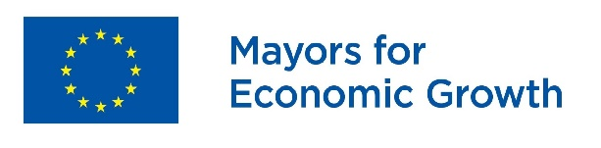
Membership Form
I, [Name of the Mayor], [Mayor] of [Name of the local authority] have been mandated by the [City Council/Assembly] on [date] to sign up to the Mayors for Economic Growth (M4EG) initiative, in full knowledge of the commitments set out in the Mayors for Economic Growth Concept and summarized below.
Therefore, my local authority principally commits to cooperate closely with the business and the civil society communities to accelerate sustainable and inclusive local economic growth, development and job creation by strengthening our efforts in at least 3 of the following 5 areas:
- Regulatory and institutional framework;
- Skills and human capital, inclusiveness;
- Land and infrastructure;
- Access to finance;
- External positioning and marketing.
As part of our efforts to fulfill these commitments, my municipality commits to:
- Develop a coalition with the private sector and civil society organizations to draw up a Local Economic Development Plan consistent with the guidelines communicated to me by the M4EG Secretariat and submit the Plan within one year following the above date of the municipal council decision;
- In partnership with the private sector and civil society organizations, undertake analyses and set out actions that will focus on growth, development and employment;
- Set clear output and result targets for those actions;
- Apply the core principles of good governance especially in terms of accountability, transparency, anti-corruption, and inclusion;
- Encourage participation in the Local Economic Development process of all stakeholders, local authorities, representatives of the business and civil society communities, universities and research institutions, representing the diversity of the local community and ensuring gender balance;
- Take account of environmental sustainability of the local economic development path;
- Report progress on the implementation of the Plan and the achieved results to the M4EG Secretariat bi-annually.
I accept that my local authority shall be suspended from the M4EG initiative – subject to prior notice in writing by the M4EG Secretariat – in case of non-submission of the above-mentioned documents (i.e. Local Economic Development Plan and bi-annual Monitoring Reports) within the established deadlines.

[Name of the Mayor] [Signature]
[Name and complete address of the local authority]
[Name, e-mail and phone number of the contact person]

